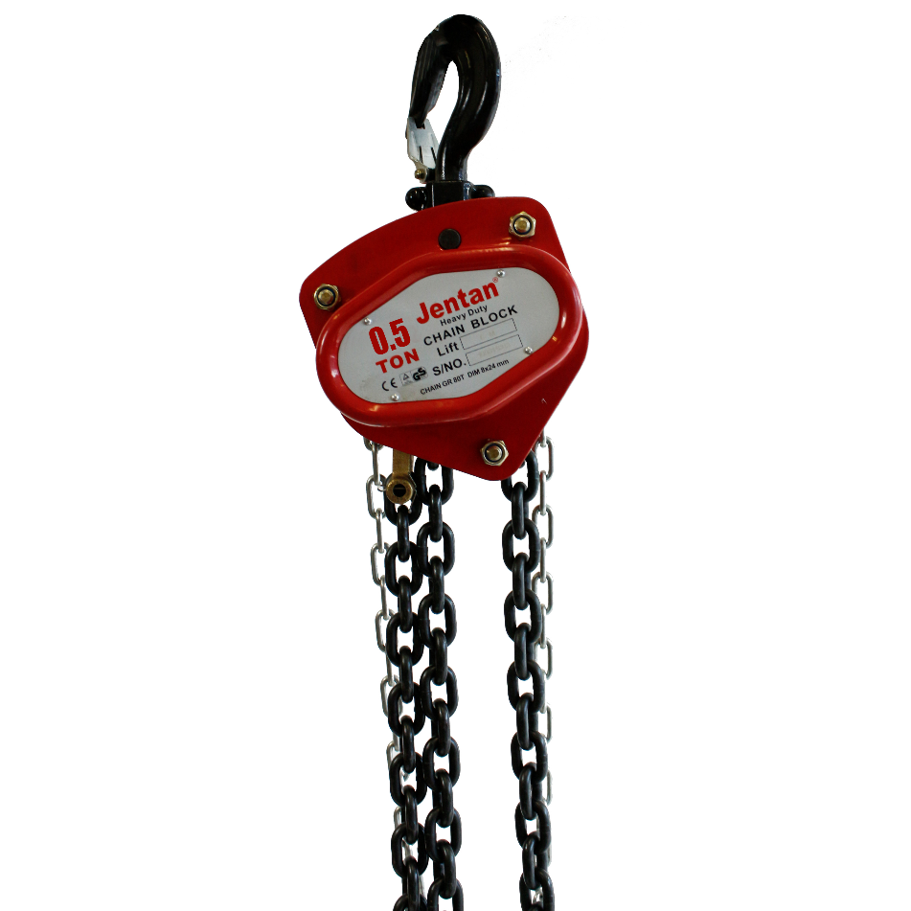

*AVAILABLE WITH 3 DIFFERENT CHAIN LENGTHS

IMPA Number: 615006
Product code:
8589 = 3 M
10623 = 6 M
10624 = 9 M

● GBO heat treated alloy load chain.
● Forged alloy Steel Hooks. Industrial rated hooks rotate 360 degrees for easy rigging.
● Sealed roller bearings. Greatly improving performance and serve life of the product.
● Load tested to 150% of capacity with test certificate.

Product specs:

TYPE | 4025
Max capacity | 500 Kg
Tested capacity | 750 KG
Max lifting height | See next page
Material | Steel alloy
Chain material | Steel alloy
Type | Manual chain hoist
Max effort required to lift | 300 N
Approvals | CE approved

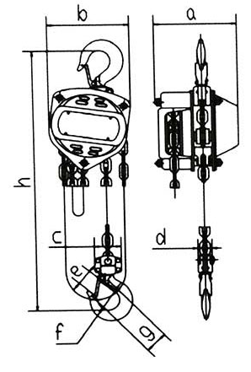

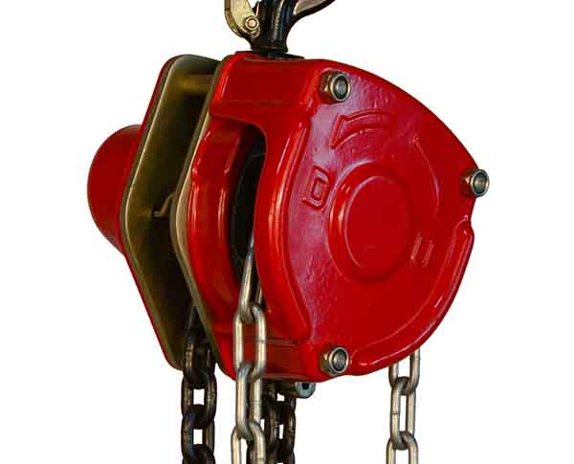

CODE | WLL (T) | Lift(m) | Load Chain |  | Dimensions (mm) |  |  |  | N.W.(kg) | G.W.(kg) | Packed size (cm)
 |  |  | Falls | Size | A | B | D | H
8589 | 0.5 | 3 | 1 | 6X18 | 137 | 137.5 | 35 | 270 | 8.7 | 10.1 | 24 x 20 x 20
10623 | 0.5 | 6 | 1 | 6X18 | 137 | 137.5 | 35 | 270 | 13.3 | 14.7 | 24 x 20 x 20
10624 | 0.5 | 9 | 1 | 6X18 | 137 | 137.5 | 35 | 270 | 18.2 | 19.7 | 27 x 21 x 21

