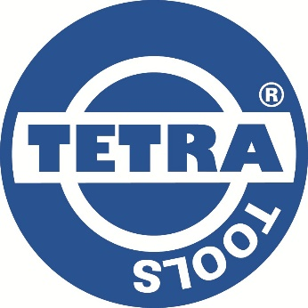

**TETRA Cargo Straps / Ratchet Straps**

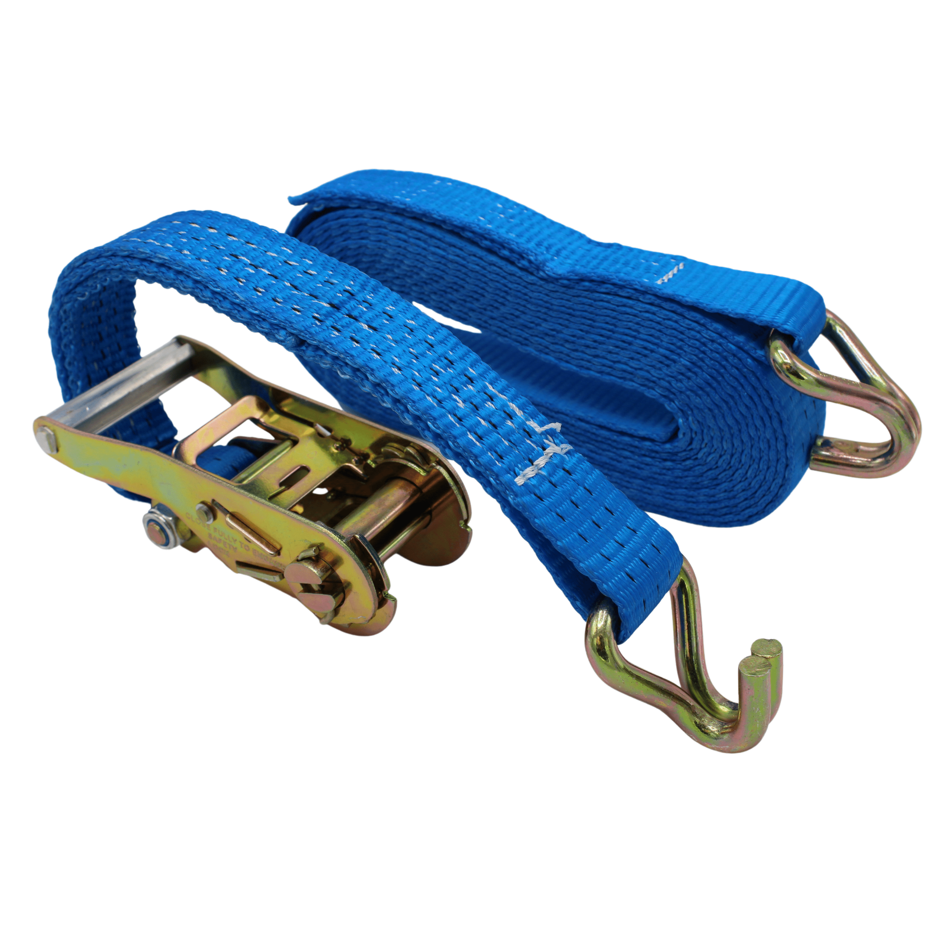

**Approvals: NEN-EN 12195-2 / CE**

Temperature range: -40 °C tot +100 °C

UV resistant

Safety factor: 2:1

All cargo straps are individually packed in a plastic cover and are supplied with the test certificate.

J-Hook material: Steel

Ratchet material: Steel

Strap material: Polyester

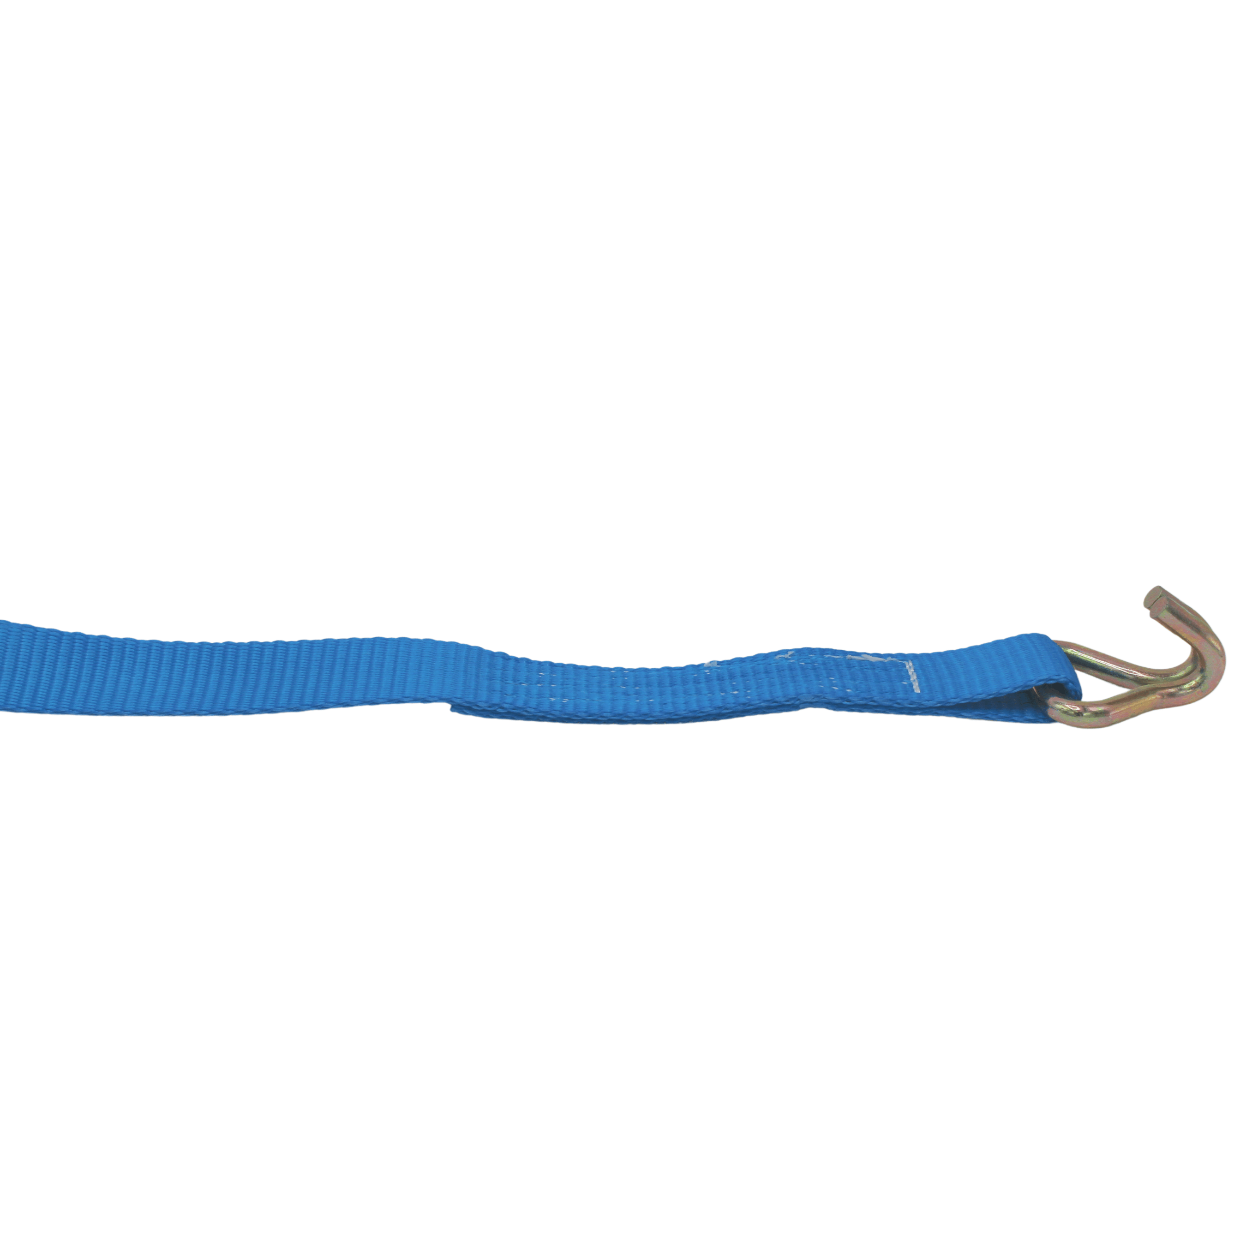



SIDE-B

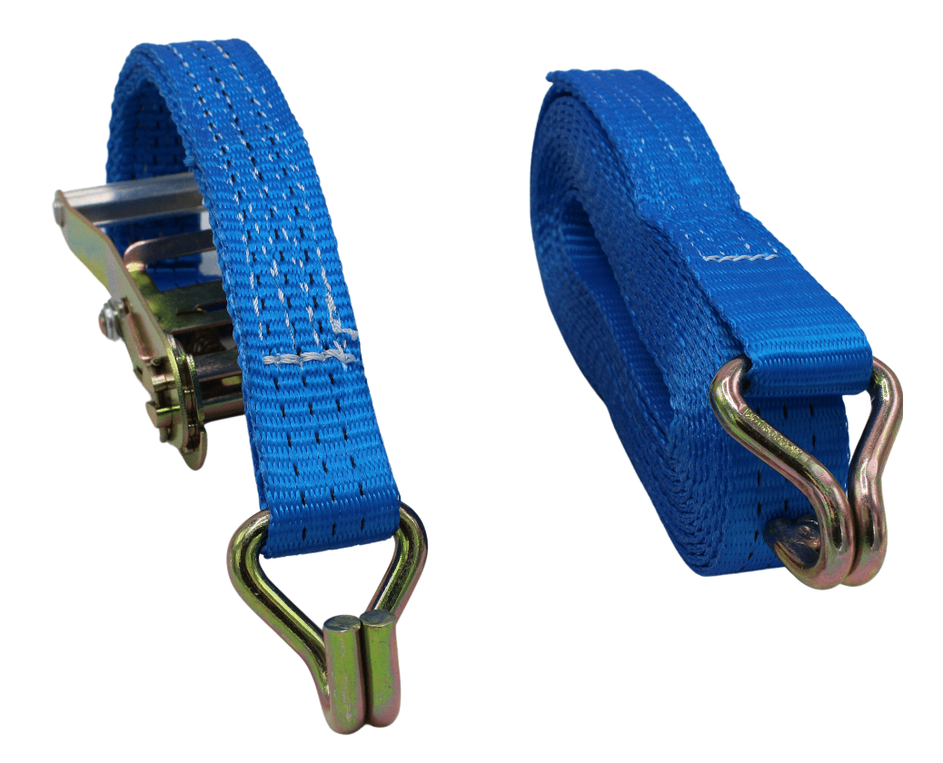

SIDE-A



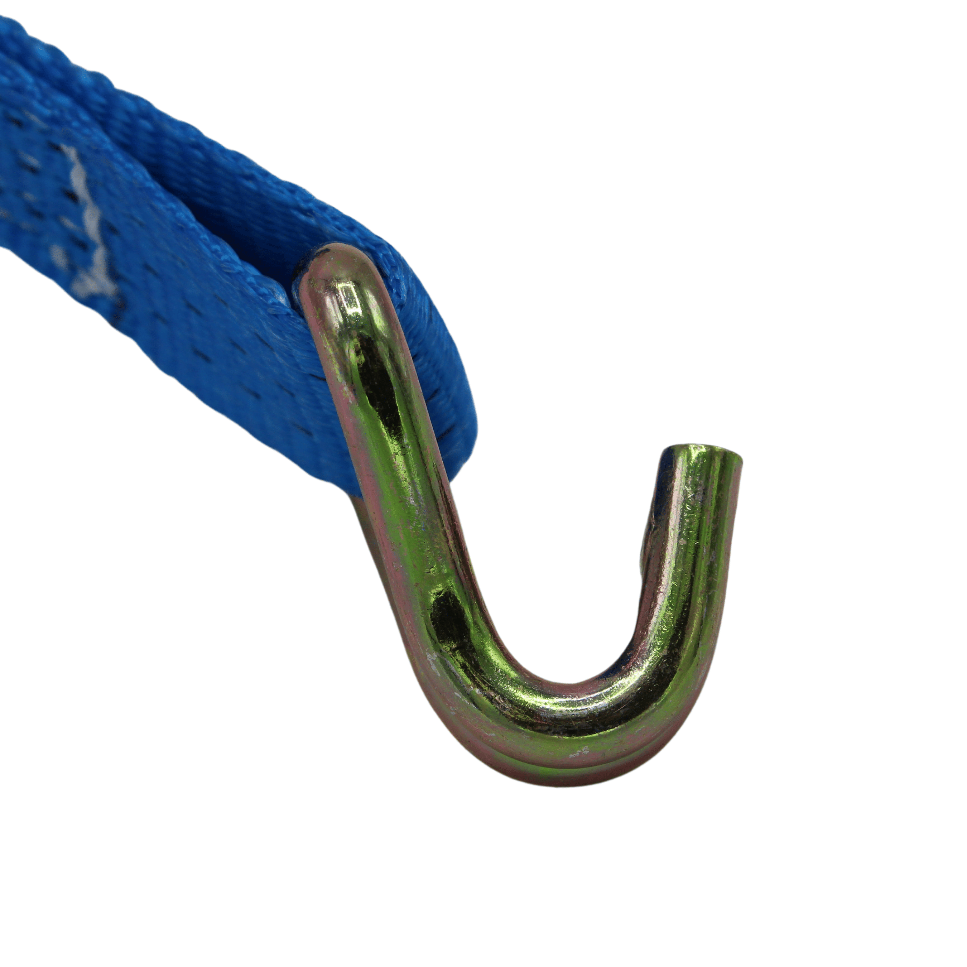

J-Hook opening

