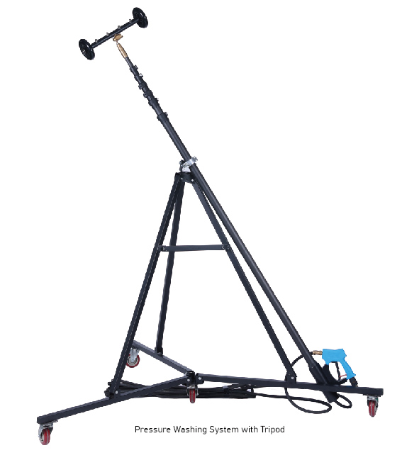

**HS- Code: 6815101000**

|  |  |
| --- | --- |
| **SPARE PARTS** | |
| 12012 | Chain Drums for Scaling Machine, Rustibus 1200, part no. 120-0156 |
|  |  |

|  |  |
| --- | --- |
| Application: | Hold cleaning pole with tripod and wall crawler 12M |
| Model: | TETRA H-12 |
| Working track: | 12M |
| Power: | 170 – 350 BARR |
| RPM: |  |
| Brand: | TETRA Tools |
| Nett weight: | 30 KG |
| Product size (LxWxH) | L 180 X H 230 X W 175 CM |
| Packed dimensions | On Request |
| HS-Code: | 6815101000 |
| IMPA-Code: | - |
| Approvals | CE approved |

**Category: Cleaning appliances**

|  |  |
| --- | --- |
| **SPARE PARTS** | |
| 12012 | Chain Drums for Scaling Machine, Rustibus 1200, part no. 120-0156 |
|  |  |

**Product code: 12392**

**Product specifications:**

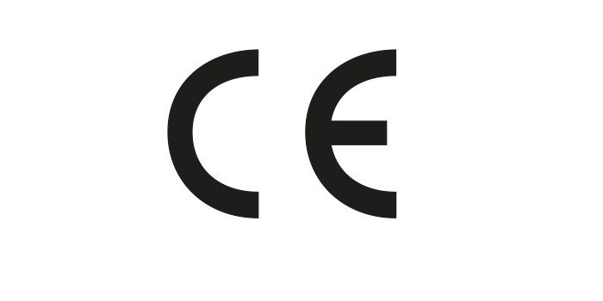

Accessories for devices:

Afbeelding met schets, tekening, cirkel, illustratie

Door AI gegenereerde inhoud is mogelijk onjuist.

**1. Pressure Trigger Gun.**

**2. Wall Crawler**

**3. High Pressure Hose**

**Installation steps:**

Afbeelding met statief

Door AI gegenereerde inhoud is mogelijk onjuist.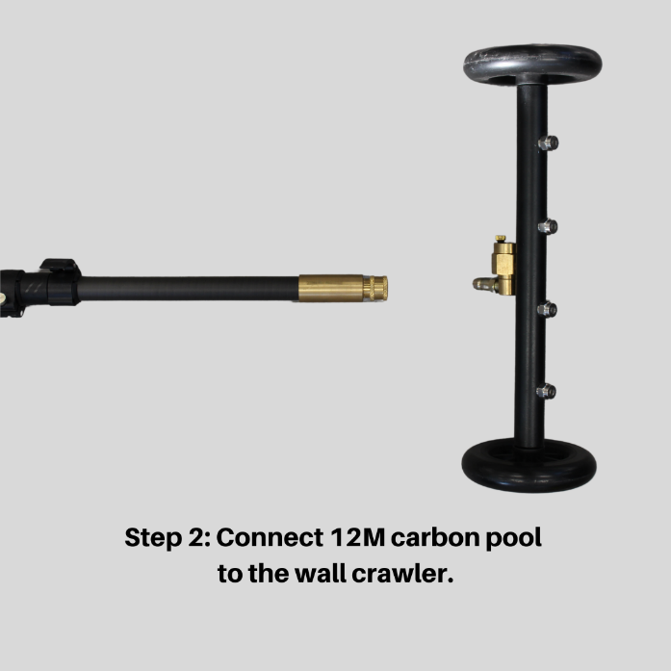

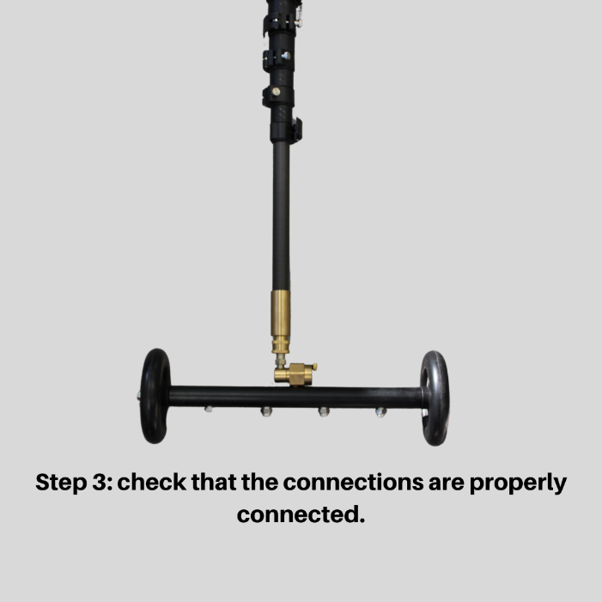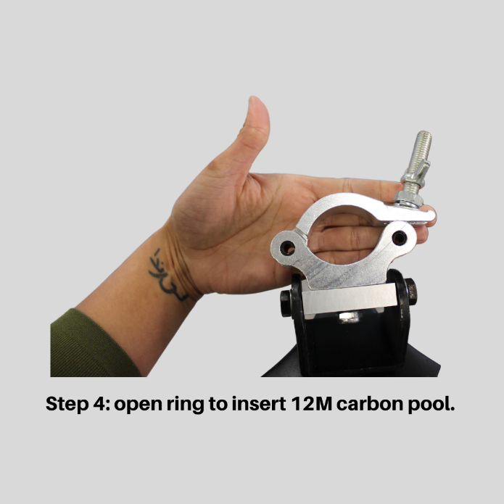

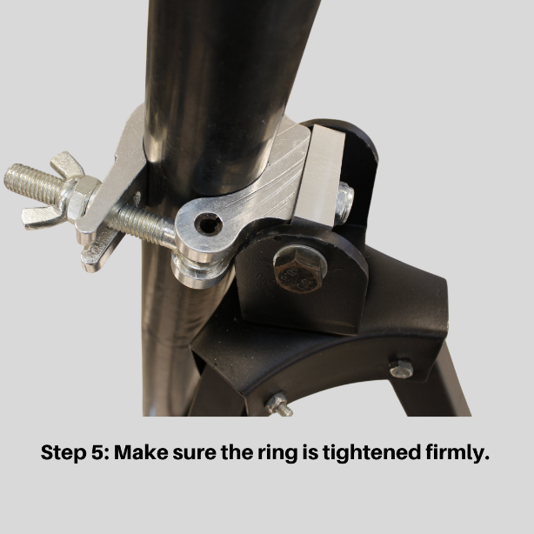

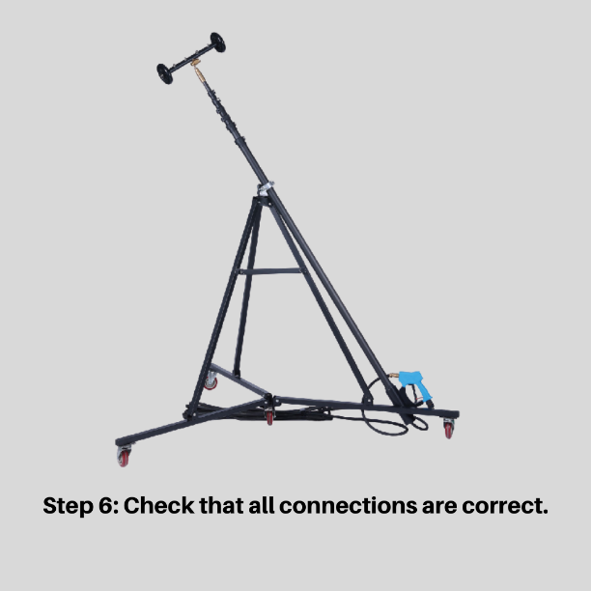

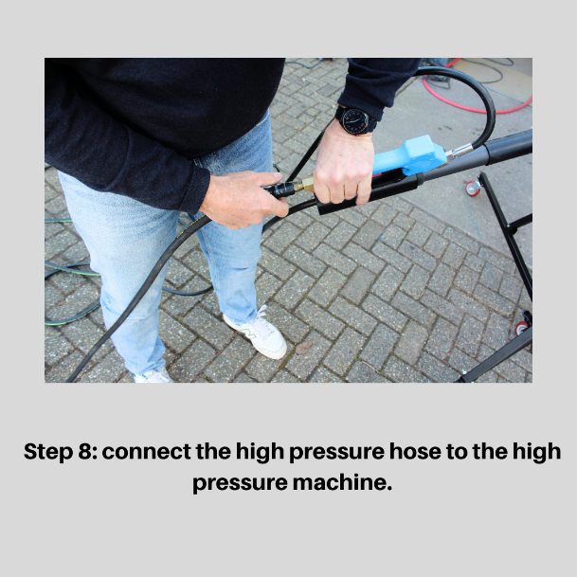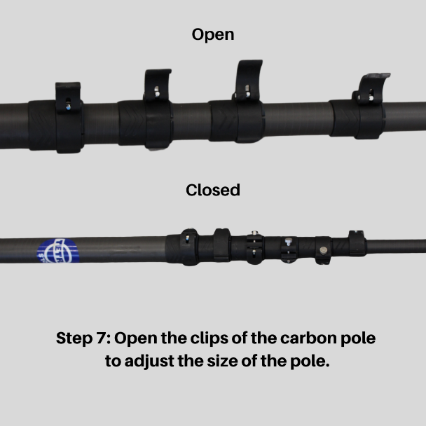

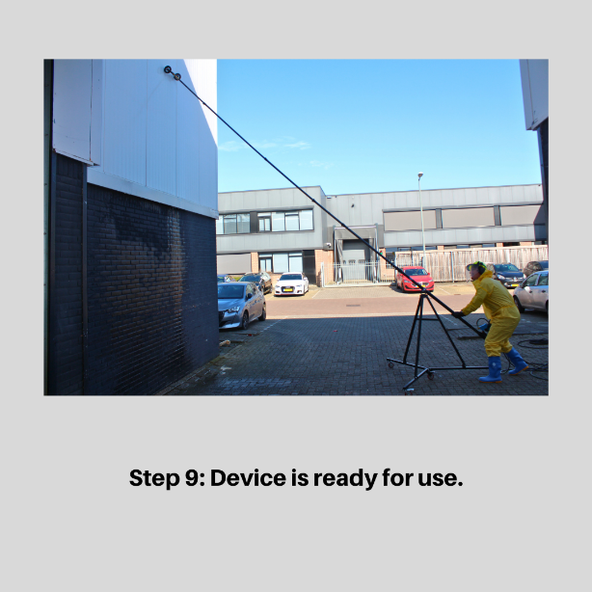

**Description:**

**Product Description: Hold Cleaning Pole with Tripod & Wall Crawler – 12m**

The **Hold Cleaning Pole with Tripod & Wall Crawler (12 meters)** is an innovative and efficient solution for cleaning ship holds and hard-to-reach surfaces. This advanced system combines a telescopic cleaning pole with a stable tripod and a Wall Crawler mechanism, allowing effortless cleaning of high and vertical surfaces without additional tools or risky climbing.

**Key Features:**

* **Extendable cleaning pole (12m)** – Easily reaches high walls and difficult-to-access areas in holds.
* **Wall Crawler system** – Ensures stable and even cleaning of vertical surfaces.
* **Tripod for extra stability** – Minimizes vibrations and increases precision during use.
* **Durable and robust materials** – Resistant to maritime conditions and intensive use.
* **Efficient cleaning** – Reduces the need for manual cleaning and enhances onboard safety.

**Applications:**

* Cleaning ship holds and cargo holds
* Cleaning walls and high surfaces without aerial work platforms
* Use in the maritime and offshore industry

**Important Considerations for Using the Hold Cleaning Pole with Tripod & Wall Crawler – 12m**

**1. Preparation and Safety Measures**

* Ensure the work area is free of obstacles and that there is enough space to extend the pole safely.
* Inspect the pole, tripod, and Wall Crawler for any damage or wear before use.
* Wear appropriate personal protective equipment (PPE), such as gloves and safety glasses, to prevent injuries.
* Make sure the surface is stable to minimize unwanted movement of the tripod.
* Start cleaning from the top and work downward for even coverage.
* Use the appropriate water pressure or cleaning agent depending on the level of contamination and the surface type.
* Move the pole in a controlled manner to avoid unnecessary strain on the Wall Crawler and the pole itself.