**HS- Code: 8467111000**

|  |  |
| --- | --- |
| **SPARE PARTS** | |
| 12012 | Chain Drums for Scaling Machine, Rustibus 1200, part no. 120-0156 |
|  |  |

|  |  |
| --- | --- |
| Application: | Pneumatic Chain Descaling Machine |
| Model: | TETRA TRB-1200 AIR |
| Working track: | 40 MM |
| Power | 750 W 50/60HZ |
| RPM | 1,410/1,715 |
| Voltage | AC 110V – AC 220V – AC 440V |
| Nett weight | 18 KG |
| Product size (LxWxH) | L 950 X H 900 X W 280 MM |
| Packed dimensions | L 100 X H 40X W 50 CM |
| HS-Code: | 8467111000 |
| IMPA-Code: | 591233 |
| Approvals | CE approved |

**IMPA Number: 591233**

|  |  |
| --- | --- |
| **SPARE PARTS** | |
| 12012 | Chain Drums for Scaling Machine, Rustibus 1200, part no. 120-0156 |
|  |  |

**Product code: 12989**

**Product specifications:**



Accessories for devices:

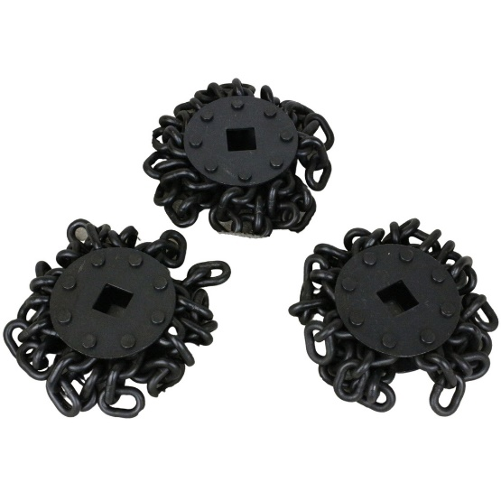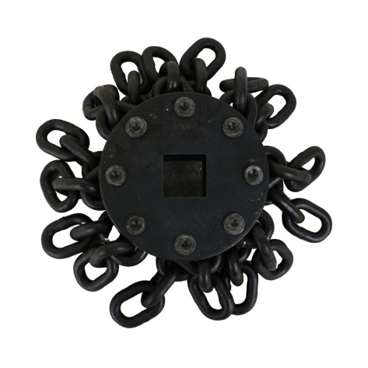

Chain drums for TRB-400 part no. 040-0156 Chain drums for TRB-1200 part no. 120-0156

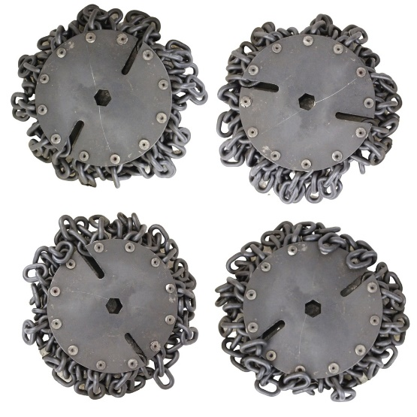

Replacement Heads for TRB-2000 part no. 200-0156

|  |  |
| --- | --- |
| **DEVICES** | |
| 12990 | TETRA TRB-2000AIR, Pneumatic Chain Descaling Machine, Chain drum working with 200mm |
| 12989 | TETRA TRB-1200AIR, Pneumatic Chain Descaling Machine, Chain drum working with 40mm |
|  |  |
|  |  |
|  |  |
| **SPARE PARTS** | |
| 12012 | Chain Drums for Scaling Machine, Rustibus 1200, part no. 120-0156 |
|  |  |

**Description:**

**Installation steps:**