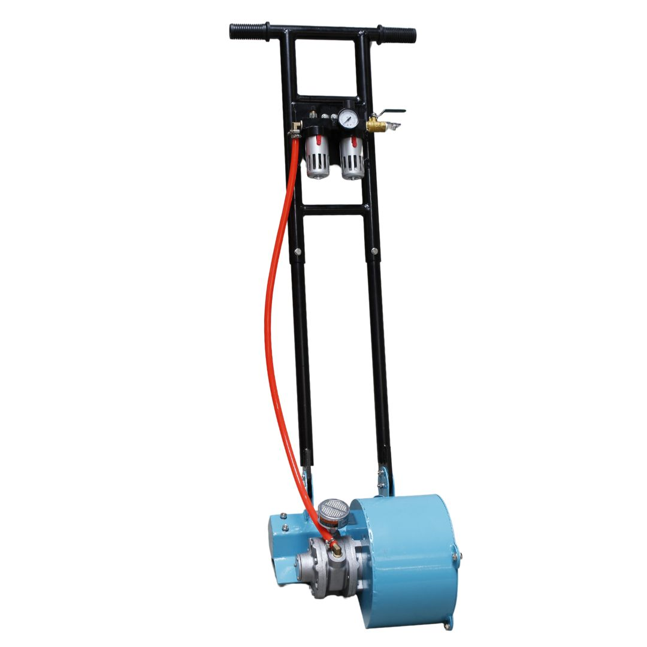

HS- Code: 8467111000
SPARE PARTS
12012 | Chain Drums for Scaling Machine, Rustibus 1200, part no. 120-0156

Application: | Pneumatic Chain Descaling Machine
Model: | TETRA TRB-1200 AIR
Working track: | 40 MM
Power | 750 W 50/60HZ
RPM | 1,410/1,715
Voltage | AC 110V – AC 220V – AC 440V
Nett weight | 18 KG
Product size (LxWxH) | L 950 X H 900 X W 280 MM
Packed dimensions | L 100 X H 40X W 50 CM
HS-Code: | 8467111000
IMPA-Code: | 591233
Approvals | CE approved

IMPA Number: 591233
SPARE PARTS
12012 | Chain Drums for Scaling Machine, Rustibus 1200, part no. 120-0156

Product code: 12989

Product specifications:



Accessories for devices:
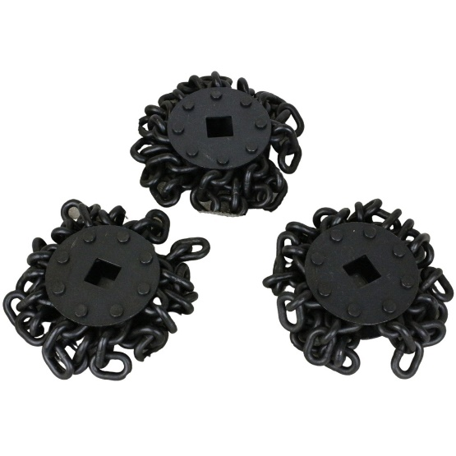
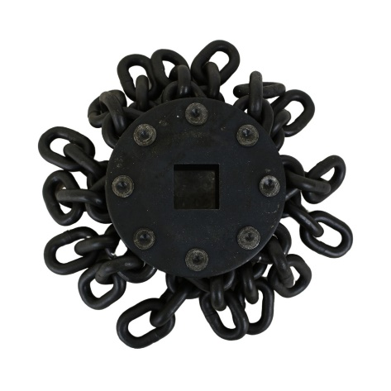

Chain drums for TRB-400 part no. 040-0156 Chain drums for TRB-1200 part no. 120-0156

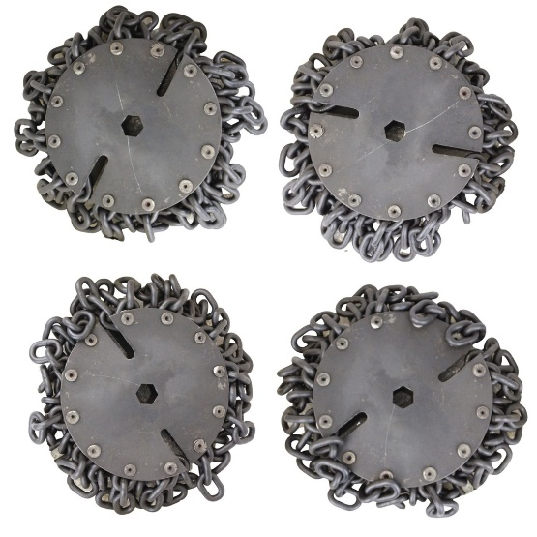

Replacement Heads for TRB-2000 part no. 200-0156

DEVICES
12990 | TETRA TRB-2000AIR, Pneumatic Chain Descaling Machine, Chain drum working with 200mm
12989 | TETRA TRB-1200AIR, Pneumatic Chain Descaling Machine, Chain drum working with 40mm
SPARE PARTS
12012 | Chain Drums for Scaling Machine, Rustibus 1200, part no. 120-0156

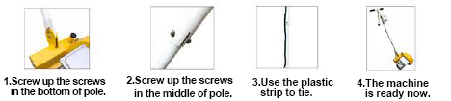
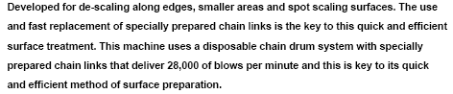
Description:
Installation steps:

