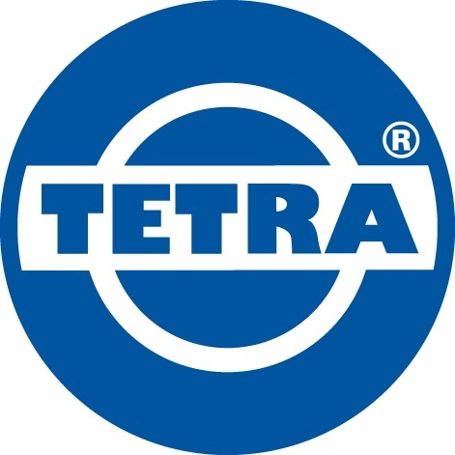

General owner’s manual
Tetra Chemical Applicator

Please make sure you always wear protective equipment
General information

Thank you for purchasing the Tetra Chemical Applicator.

The Tetra Chemical Applicator is a ready to use kit to apply chemicals during the hold cleaning process up to 14 meters high, by using an air driven pump and an extendable lance.

- Working with chemicals is potentially dangerous if the safety instructions are not followed up securely so please read the full manual before setting up the kit.
- This kit does not contain the chemicals to be applied; also follow all safety instructions for the intended chemicals.
Features:
Each package consist of the following items:
- Tetra TDPK-15 PPT, polypropylene diaphragm pump with 1/2” connections.
- 50 meter discharge hose assy with 12M. telescopic lance and nozzle.
- 35 meter air supply hose for TDPK-15 PPT.
- Supply hose ½ 10M. with camlock connection.
- Supply hose ½ 40M. with camlock and GEKA connection.

Optional extras:
For all users and bystanders a PPE kit is recommended or, depending on the used chemicals, a crucial extra;
- Chemical resistant boots
- Chemical resistant overall
- Chemical resistant gloves
- Full face mask with filter for use with intended chemicals

Pump manual:
For the diaphragm pump in this kit we add a separate manual covering all the Tetra diaphragm pumps in including the TDPK-15 PPT in this kit.

Safety Instructions

To work safely and keep your pump in a good condition, please follow the following instructions:

Equipment misuse can cause the equipment to rupture or malfunction and result in serious injury.
- This equipment is for professional use only.
- Read all instruction manuals, tags, and labels before operating the equipment.
- Use the equipment only for its intended purpose. If you are not sure, call your Tetra distributor.
- Do not alter or modify this equipment. Use only genuine Tetra parts and accessories.
- Check equipment daily. Repair or replace worn or damaged parts immediately.
- Do not exceed the maximum working pressure of the lowest rated component in your system.
- Use fluids and solvents that are compatible with the equipment wetted parts. Refer to the Technical Data section of all equipment manuals.
- Route hoses away from traffic areas, sharp edges, moving parts, and hot surfaces. Do not expose hoses to temperatures above the maximum rated temperature.
- Wear eye, face, hearing and body protection when operating this equipment.
- Do not lift pressurized equipment.
- Do not kink or overbend hoses or use hoses to pull equipment.
- Comply with all applicable local, state, and national fire, electrical, and safety regulations.
- Never exceed the maximum air inlet pressure of 8.4 bar
- Never point the gun at people of animals.
- Use both hands when spraying.
- Never spray to electric wiring or directly to the pressure washer.

Images of setting the device:

On the next page you will find an explanation of how the product should be installed.
If you have any questions about installing the product, do not hesitate to contact our specialist.
Phone: +31 (0)10 - 2620844
E-mail: info@technotrading.nl

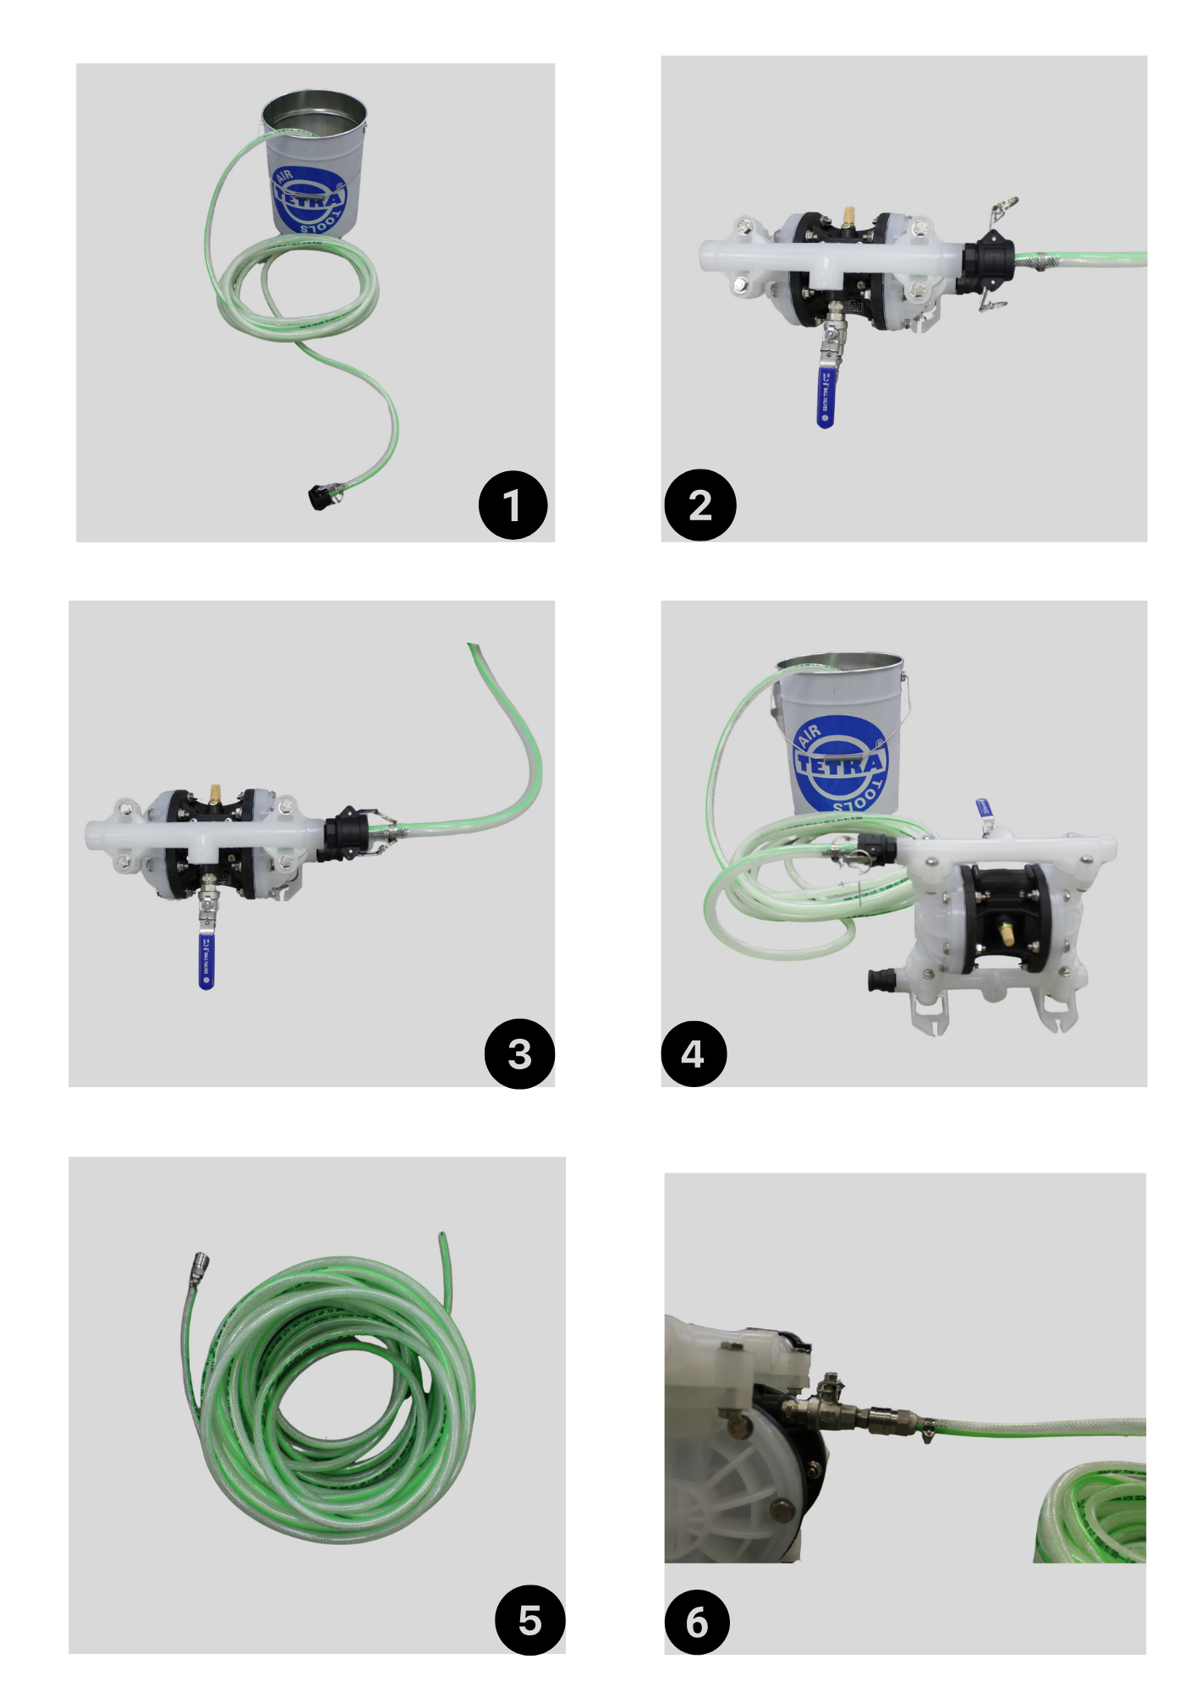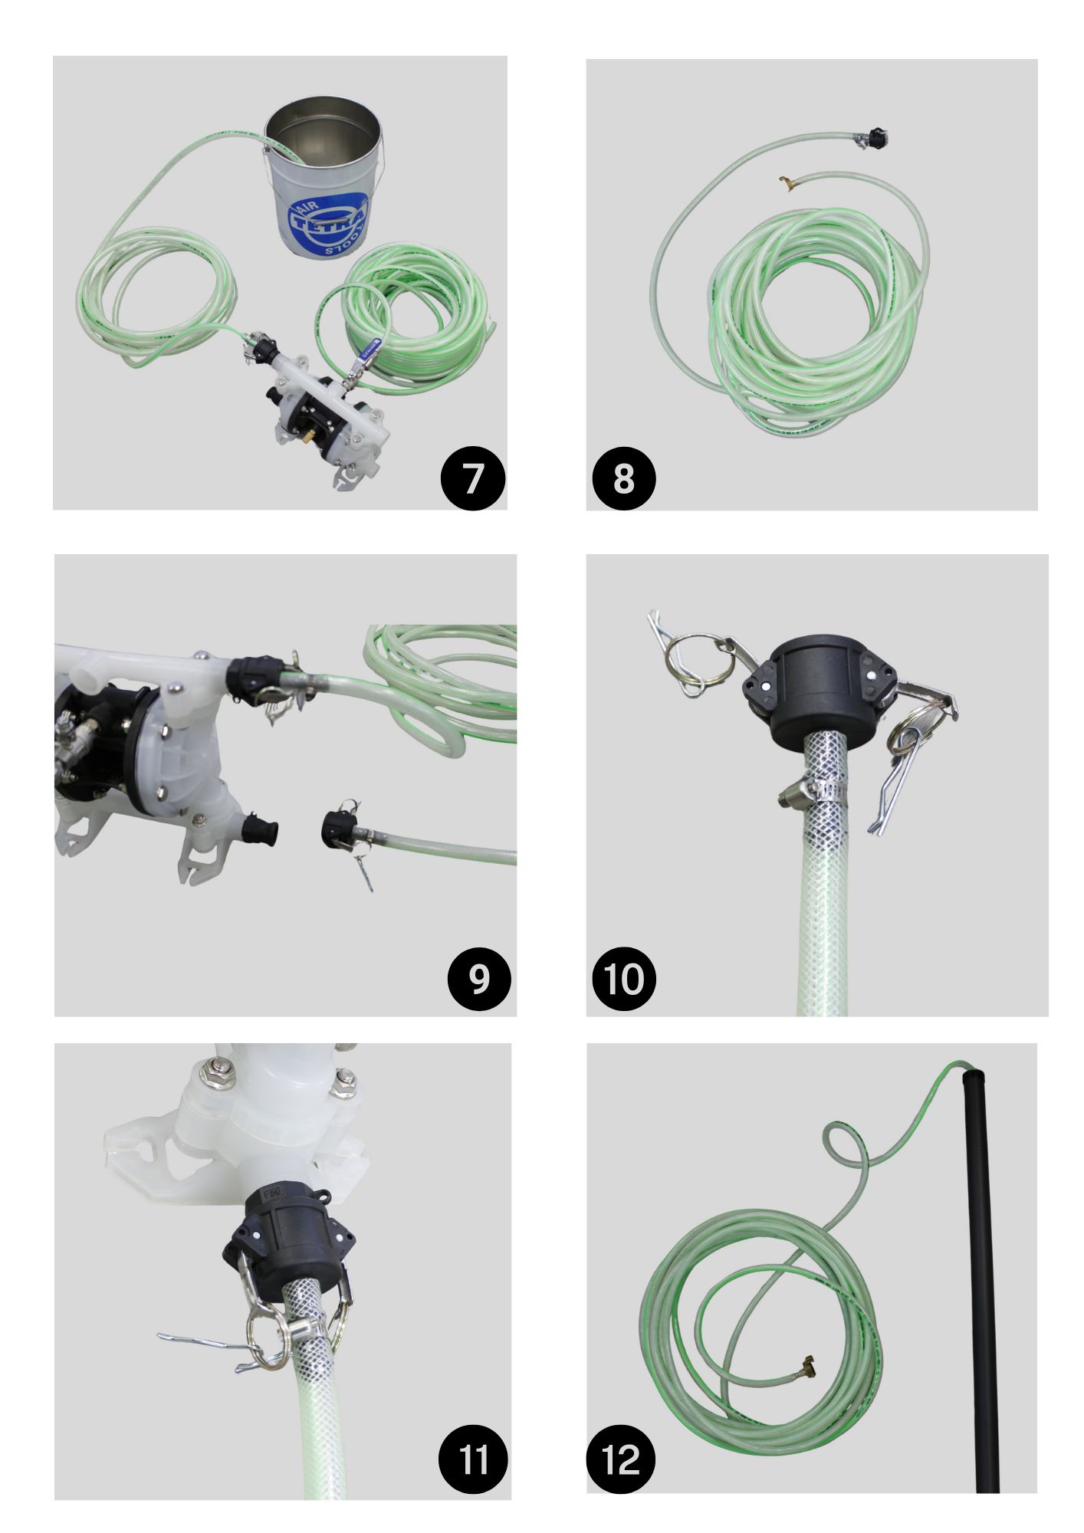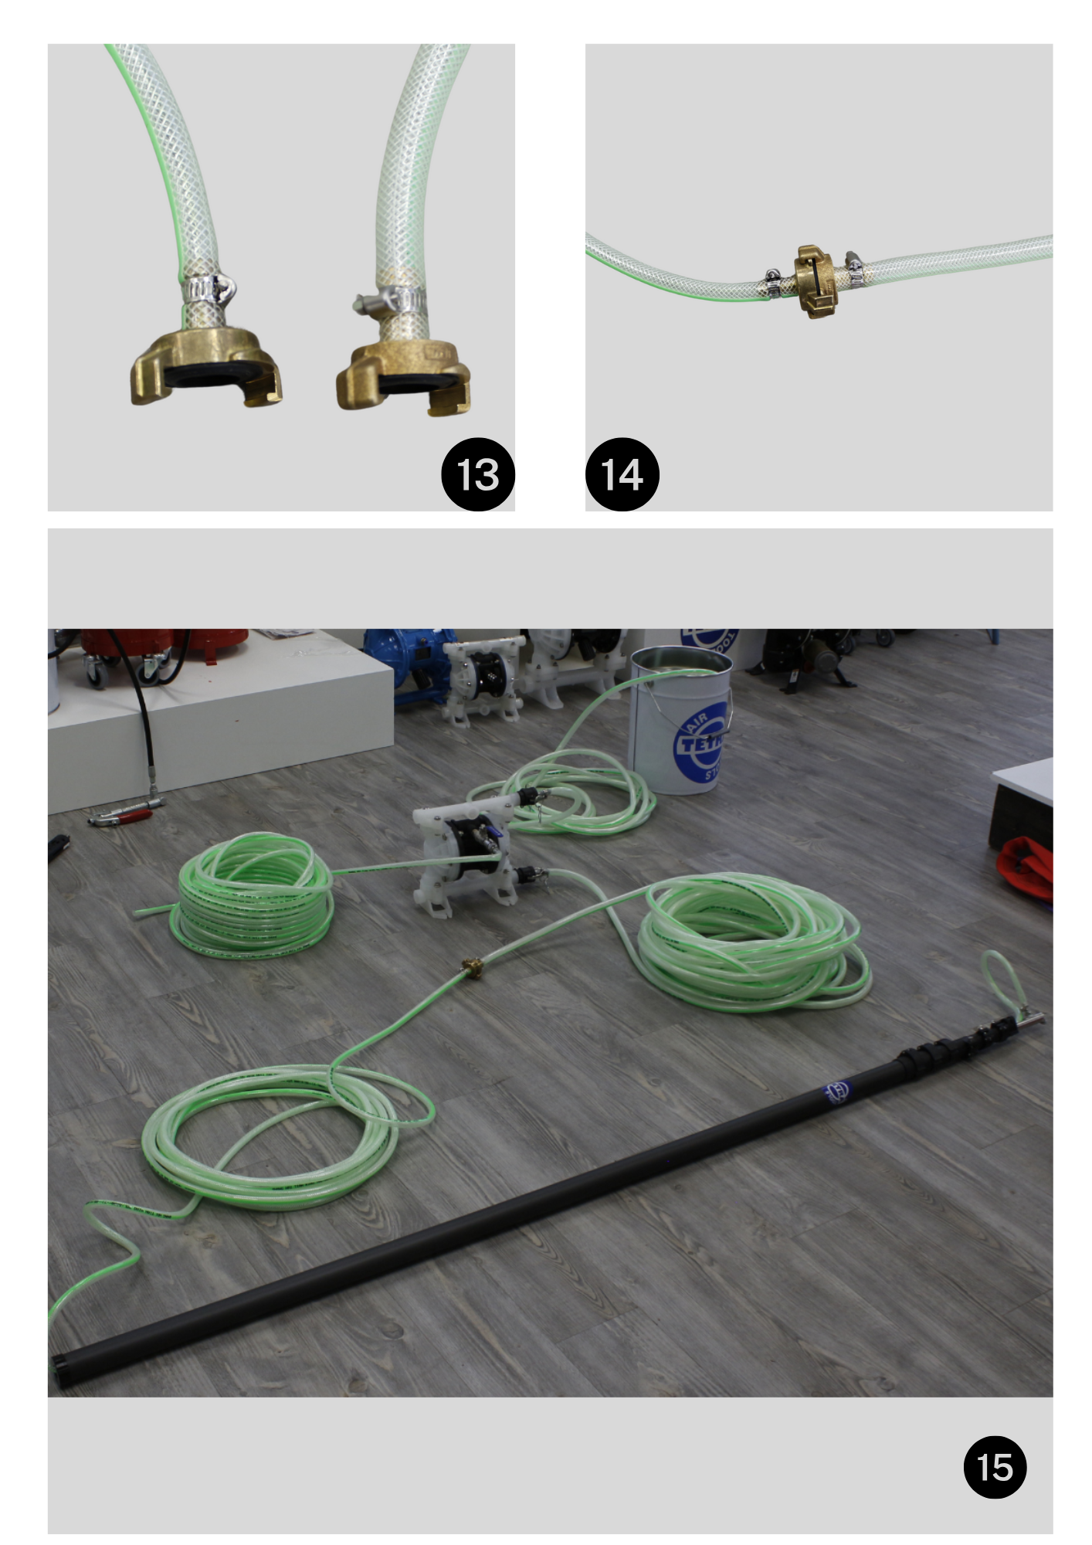

Setting the device:

Step 1: Place the hose in to the liquid.

Step 2: Place the camlock connection on the top side of the diaphragm pump.

Step 3: Lock the camlock to the diaphragm pump by pushing the handles down.

Step 4: Check whether the connection of the camlock corresponds to the picture.

Step 5: Grab the air hose to connect to the diaphragm pump.

Step 6: Connect the air hose to the ball valve by tightening the connection on the diaphragm pump.

Step 7: Check whether the connection of the air hose corresponds to the picture.

Step 8: Grab the supply hose with camlock connection and GEKA connection.

Step 9: Connect the camlock connection on the below side of the diaphragm pump.

Step 10: Grab the open camlock connection.

Step 11: Lock the camlock to the diaphragm pump by pushing the handles down.

Step 12: Grab the telescopic lance with the GEKA connection.

Step 13: Connect the GEKA connection of the telescopic lens to the GEKA connection of the supply hose by twisting them together.

Step 14: Check whether the GEKA connection are properly connected like image.

Step 15: Check if product is installed as image

Domestic
(Industrial) Cleaning
Abrasives, Finishing and Grinding
Accessories
Air Treatment
Anti-piracy
Couplings
Fans, Heaters & Tubes
Lifting & Hoisting
Lighting
Oil & Grease Tools
Paint Spray Equipment
Pumps
Rust removal and Sandblasting
Safety Equipment
Tools

WWW.TECHNOTRADING.NL









Distributor of:

