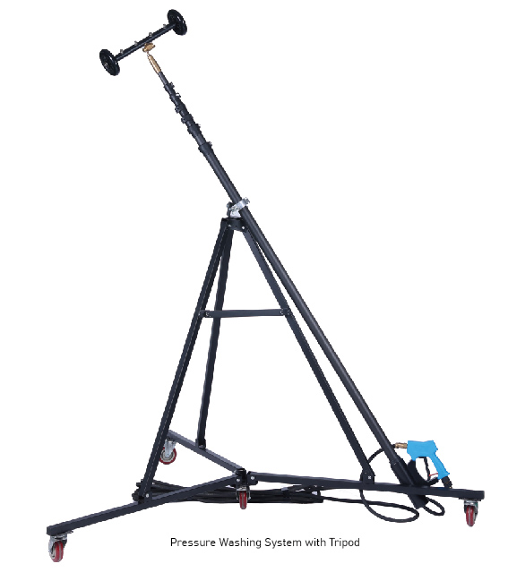

HS- Code: 6815101000
SPARE PARTS
12012 | Chain Drums for Scaling Machine, Rustibus 1200, part no. 120-0156

Application: | Hold cleaning pole with tripod and wall crawler 12M
Model: | TETRA H-12
Working track: | 12M
Power: | 170 – 350 BARR
RPM:
Brand: | TETRA Tools
Nett weight: | 30 KG
Product size (LxWxH) | L 180 X H 230 X W 175 CM
Packed dimensions | On Request
HS-Code: | 6815101000
IMPA-Code: | -
Approvals | CE approved

Category: Cleaning appliances
SPARE PARTS
12012 | Chain Drums for Scaling Machine, Rustibus 1200, part no. 120-0156

Product code: 12392

Product specifications:

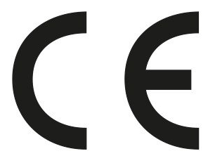

Accessories for devices:
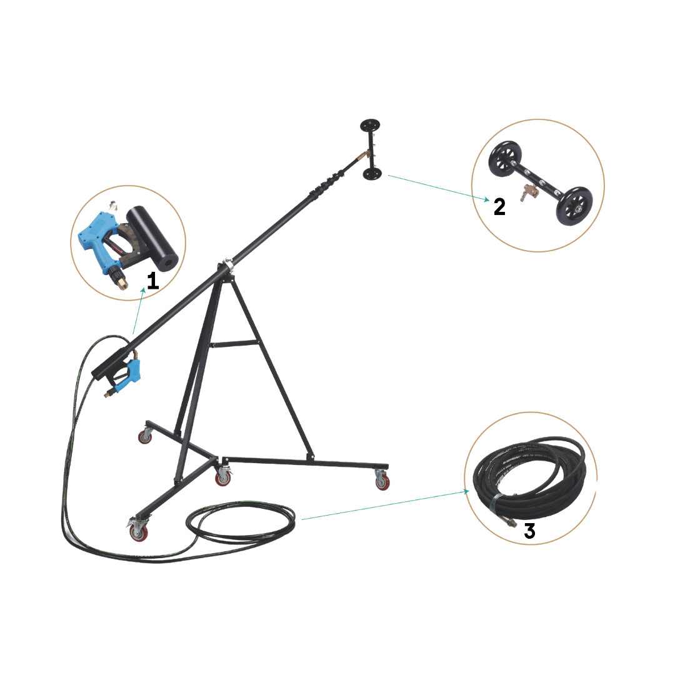
1. Pressure Trigger Gun.
2. Wall Crawler
3. High Pressure Hose

Installation steps:

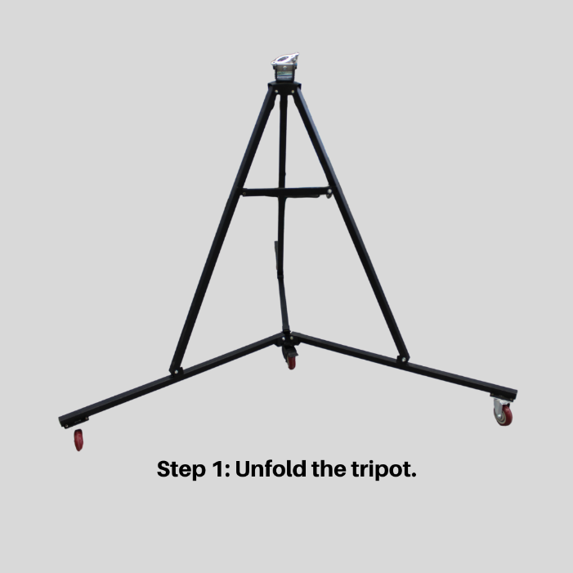
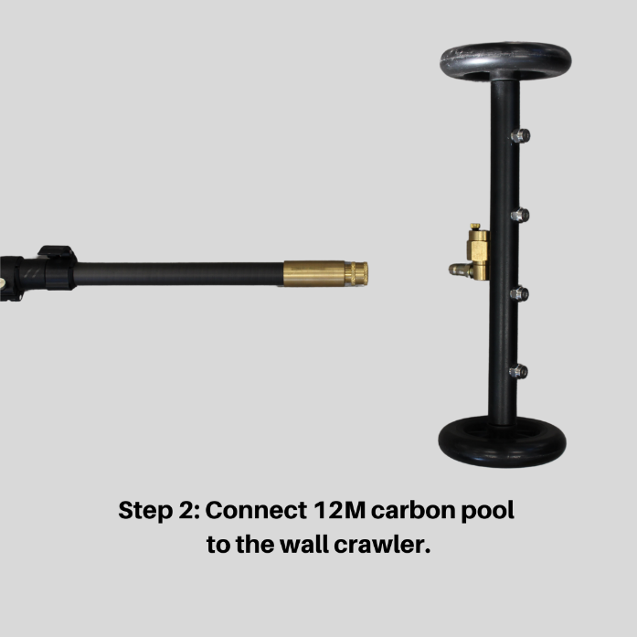

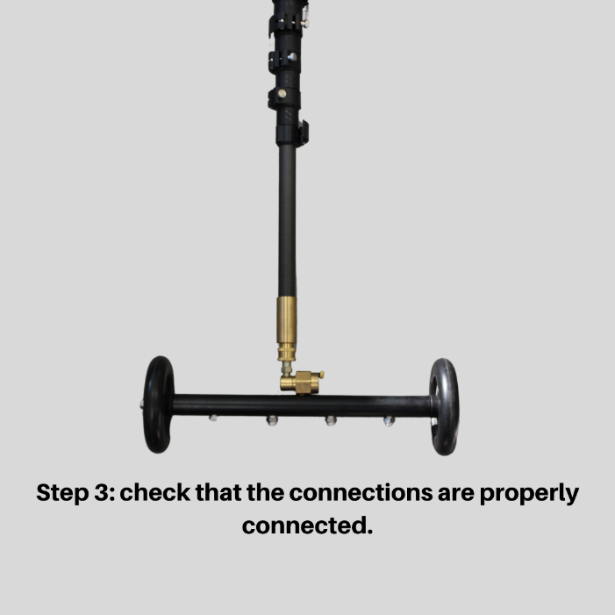
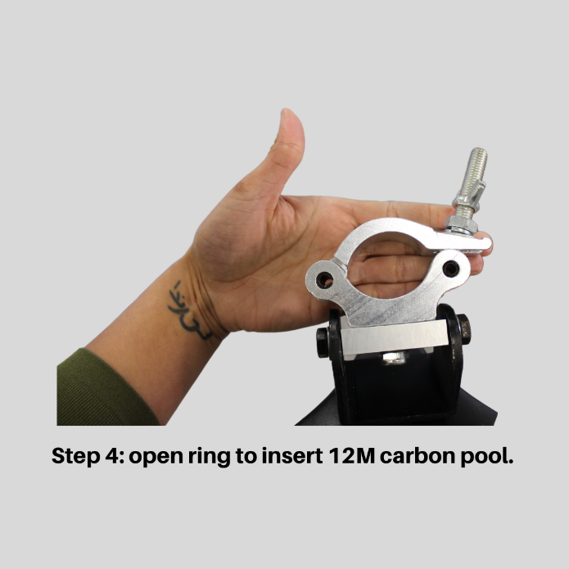

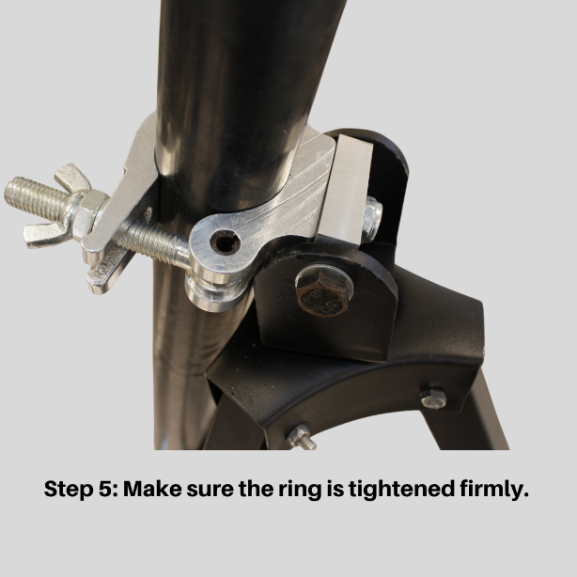
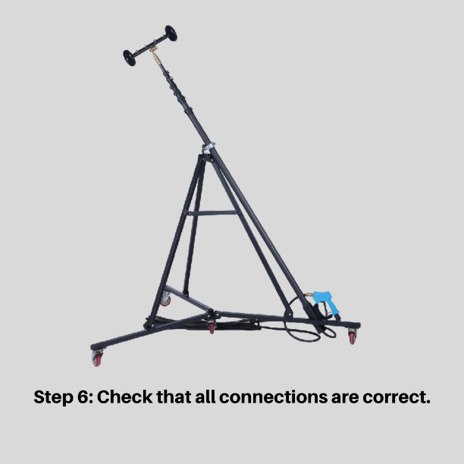

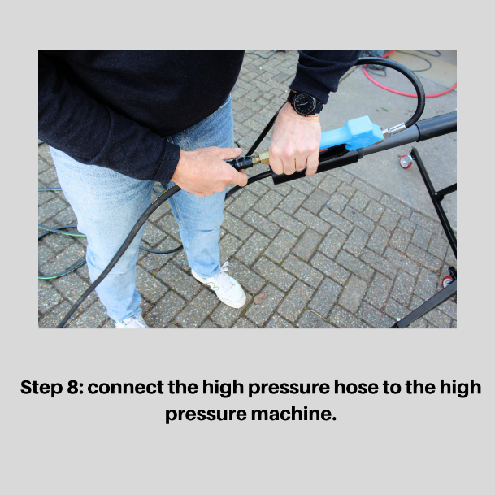
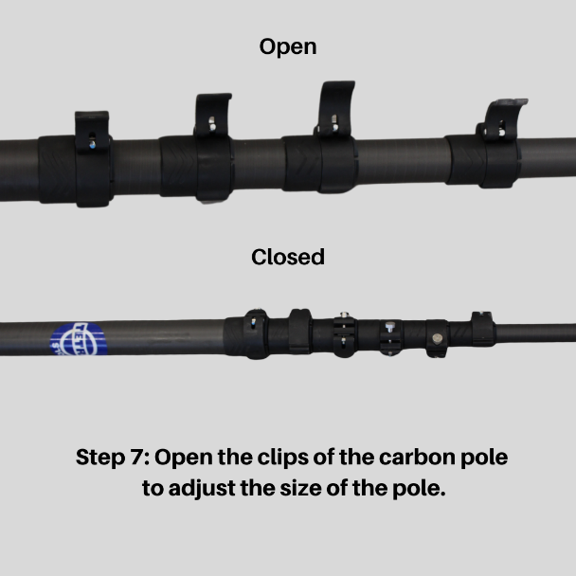

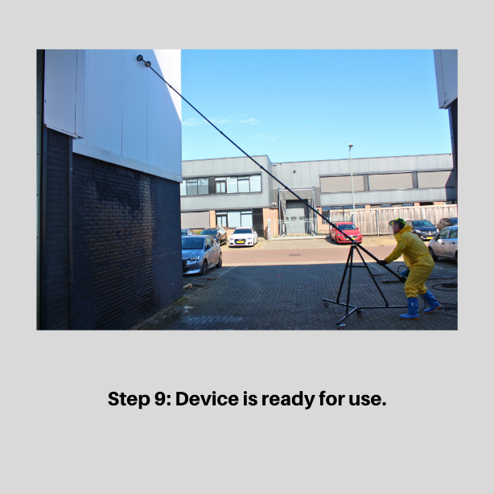

Description:

Product Description: Hold Cleaning Pole with Tripod & Wall Crawler – 12m
The Hold Cleaning Pole with Tripod & Wall Crawler (12 meters) is an innovative and efficient solution for cleaning ship holds and hard-to-reach surfaces. This advanced system combines a telescopic cleaning pole with a stable tripod and a Wall Crawler mechanism, allowing effortless cleaning of high and vertical surfaces without additional tools or risky climbing.
Key Features:
- Extendable cleaning pole (12m) – Easily reaches high walls and difficult-to-access areas in holds.
- Wall Crawler system – Ensures stable and even cleaning of vertical surfaces.
- Tripod for extra stability – Minimizes vibrations and increases precision during use.
- Durable and robust materials – Resistant to maritime conditions and intensive use.
- Efficient cleaning – Reduces the need for manual cleaning and enhances onboard safety.
Applications:
- Cleaning ship holds and cargo holds
- Cleaning walls and high surfaces without aerial work platforms
- Use in the maritime and offshore industry
Important Considerations for Using the Hold Cleaning Pole with Tripod & Wall Crawler – 12m
1. Preparation and Safety Measures
- Ensure the work area is free of obstacles and that there is enough space to extend the pole safely.
- Inspect the pole, tripod, and Wall Crawler for any damage or wear before use.
- Wear appropriate personal protective equipment (PPE), such as gloves and safety glasses, to prevent injuries.
- Make sure the surface is stable to minimize unwanted movement of the tripod.
- Start cleaning from the top and work downward for even coverage.
- Use the appropriate water pressure or cleaning agent depending on the level of contamination and the surface type.
- Move the pole in a controlled manner to avoid unnecessary strain on the Wall Crawler and the pole itself.

