

**JTEC-A 0.5TS, Electric Chain Hoist, 220V/1ph/60Hz, Single chain, Single speed, No trolley, 3 m chain incl, Lifting cap 0.5 ton**

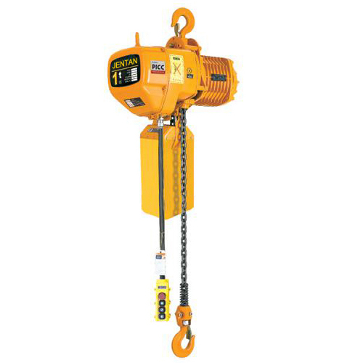

|  |  |
| --- | --- |
| **Specs:** | |
| **size (H x L x B)** | 440 mm x 460 mm |
| **Speed type** | Single speed (6.8 m/min) |
| **Test Load** | 6.25 KN |
| **Workload** | 0.5 ton |
| **Standard lift** | 3 m |
| **Nett weight** | ? kg |
| **Gross weight** | ? kg |

**SKU: 8558**

**IMPA: 591307**