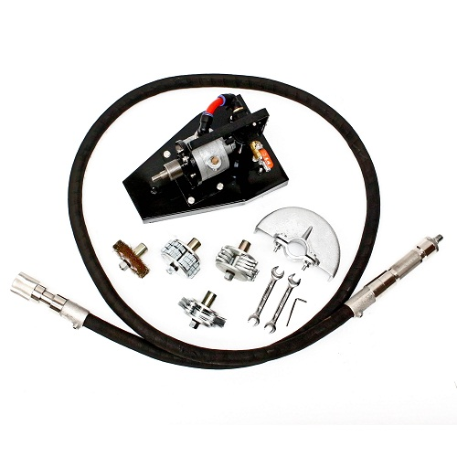

Including cutter blade assembly (see next page)

Product specs:

 | TETRA TC-60
SKU | 2395
IMPA | 591251
Max air consumption | 0.8 m3/min
No load speed | 5000 RPM
Nett weight (incl cutters) | 25 KG
Dimensions Package | 44 x 37 60



STANDARD ACCESSORIES
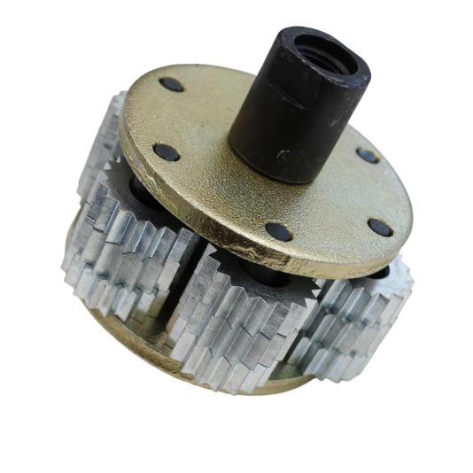
SKU : 2396 - Spare parts for Scaling Machine KC-50/60, No 1, HD Tool, for Heavy rusting.
IMPA: 591255
Excellent for heavy rusting surfaces.
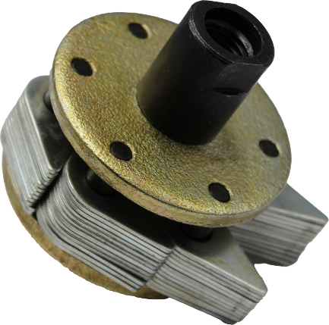
SKU: 2403 - Spare parts for Scaling Machine KC-50/60, No 2, LG Brush assembly
IMPA: 591260
Excelent for light rusting surfaces.

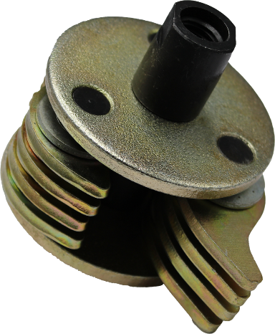
SKU: 2410 - Spare parts for Scaling Machine KC-50/60, No 4, Hammer Head, for Wide rusting.
IMPA: 591266
Excelent for wide rusting surfaces.

Contents:
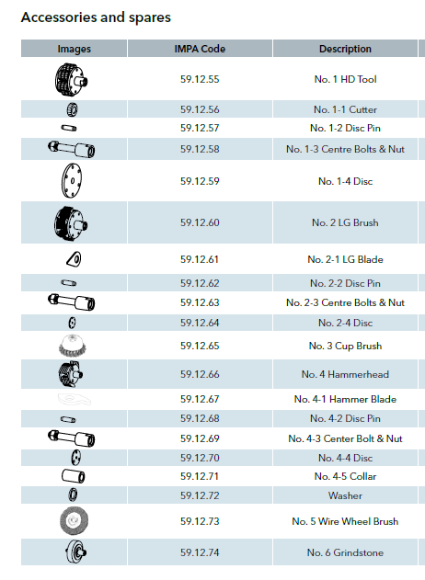
- L12 ½ Lubricator
- Muffler
- Air motor size 4
- Flexible shaft 2M.

