AVAILABLE IN 2 MODELS*
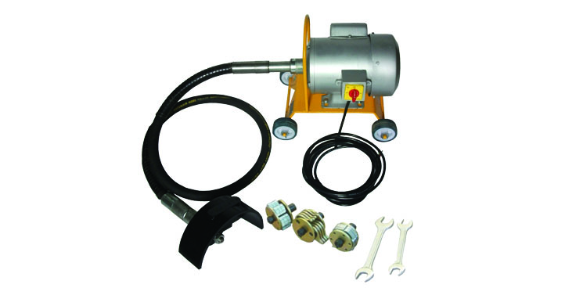

Including cutter blade assembly (see next page)

Product specs:

 | TETRA TC-50 110V | TETRA TC-50 220V
SKU | 2389 | 2391
IMPA | 591217 | 591218
H.P. | 0.75 HP | 0.75 HP
Voltage | 110V | 220V
Power rating | 60HZ | 50/60HZ
Power cable incl. | YES | YES
Working speed | 2800 RPM | 2850 RPM
Nett weight (incl cutters) | 48 KG | 48 KG
Dimensions Package | 55 x 47 x 45 | 55 x 47 x 45
Coonection | 5/8 thread | 5/8 thread



STANDARD ACCESSORIES
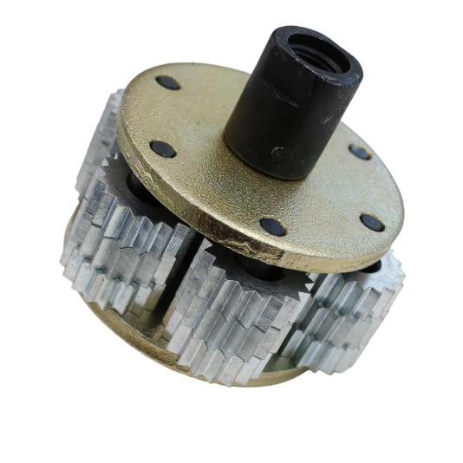
SKU : 2396 - Spare parts for Scaling Machine KC-50/60, No 1, HD Tool, for Heavy rusting.
IMPA: 591255
Excellent for heavy rusting surfaces.
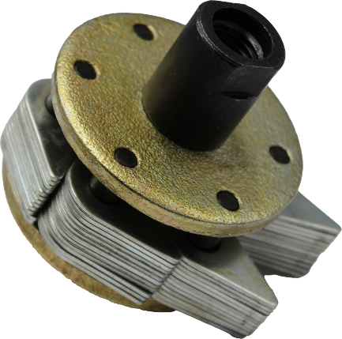
SKU: 2403 - Spare parts for Scaling Machine KC-50/60, No 2, LG Brush assembly
IMPA: 591260
Excelent for light rusting surfaces.

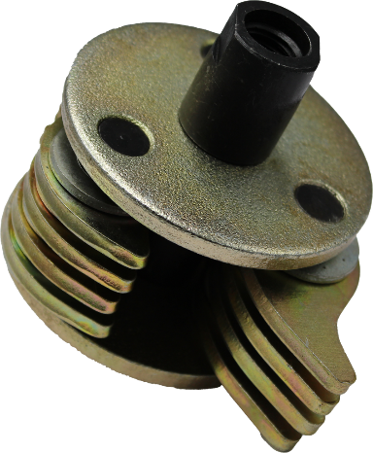
SKU: 2410 - Spare parts for Scaling Machine KC-50/60, No 4, Hammer Head, for Wide rusting.
IMPA: 591266
Excelent for wide rusting surfaces.

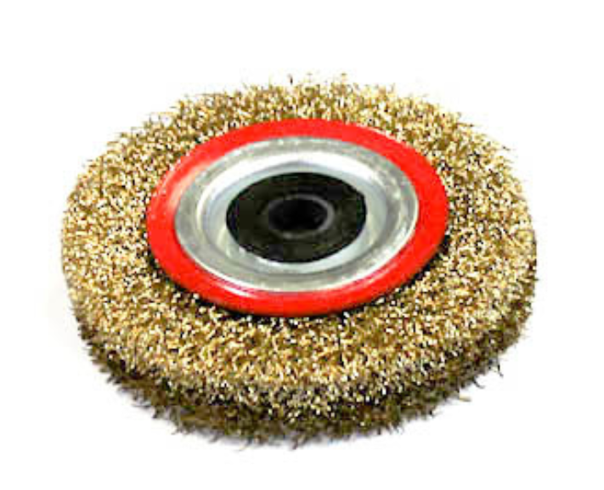
SKU: 3016 - Wire Wheel Brush, standard/crimped, steel, 75 mm dia, 3/8" (10 mm) arbor, steel. IMPA: 510771
Excelent for wide rusting surfaces.

Contents:
- A tool kit containing – 2 Nos – Fixed spanner 20/22
- 1 No – electric motor mounted on trolley
- 5 Meter cvable – 1 No.
- Rubberised shaft assembly
- Rubbek wheel guard & clamp
- Protective cover

