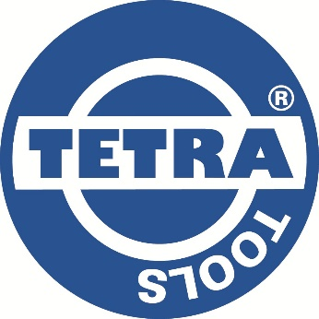


TETRA Cargo Straps / Ratchet Straps

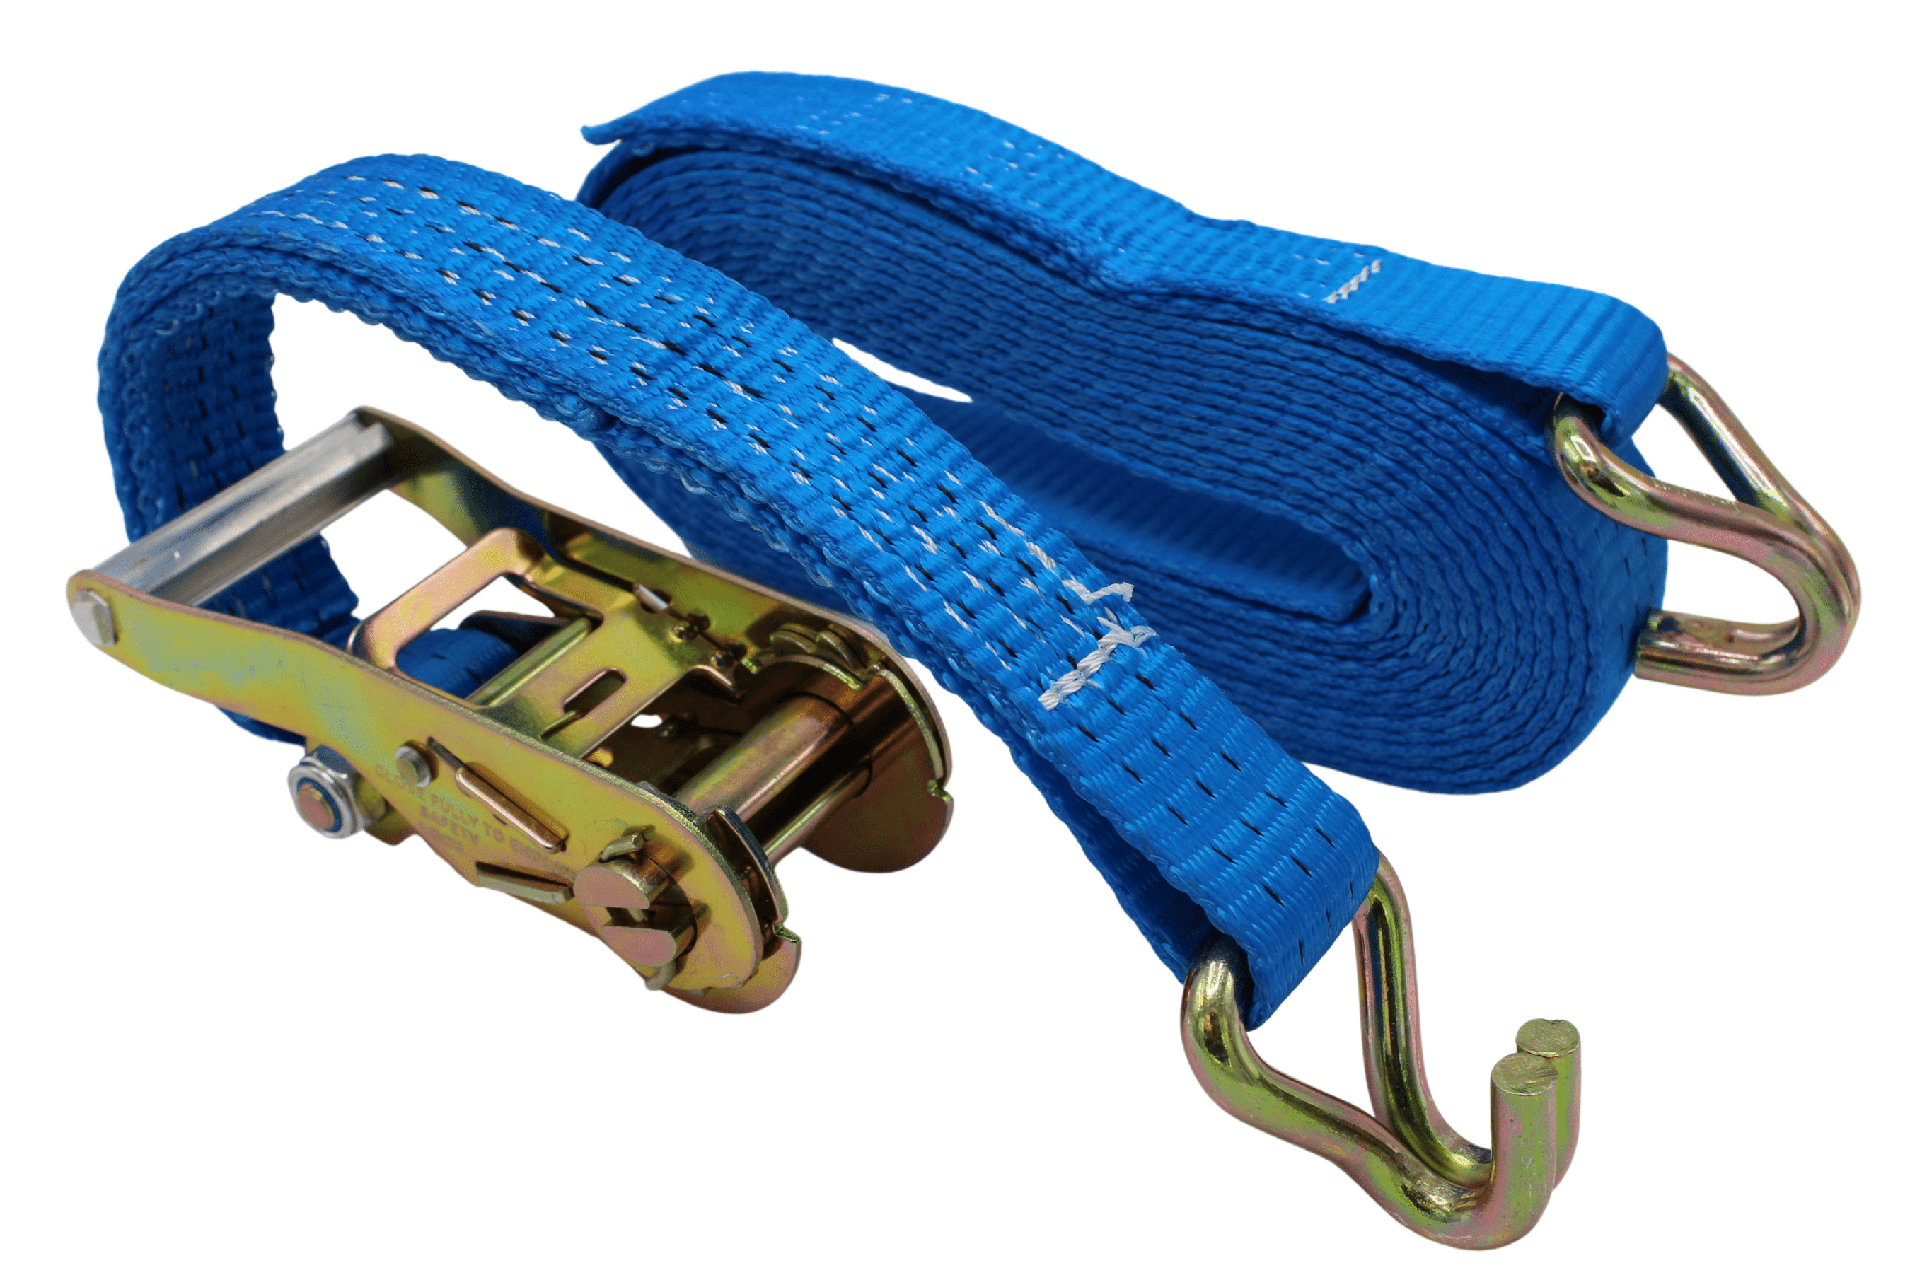

Approvals: NEN-EN 12195-2 / CE

Temperature range: -40 °C tot +100 °C
UV resistant

Safety factor: 2:1

All cargo straps are individually packed in a plastic cover and are supplied with the test certificate.

J-Hook material: Steel
Ratchet material: Steel
Strap material: Polyester

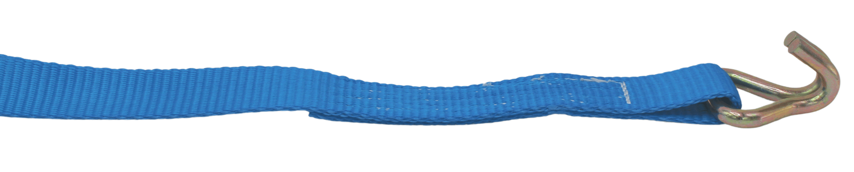



SIDE-B
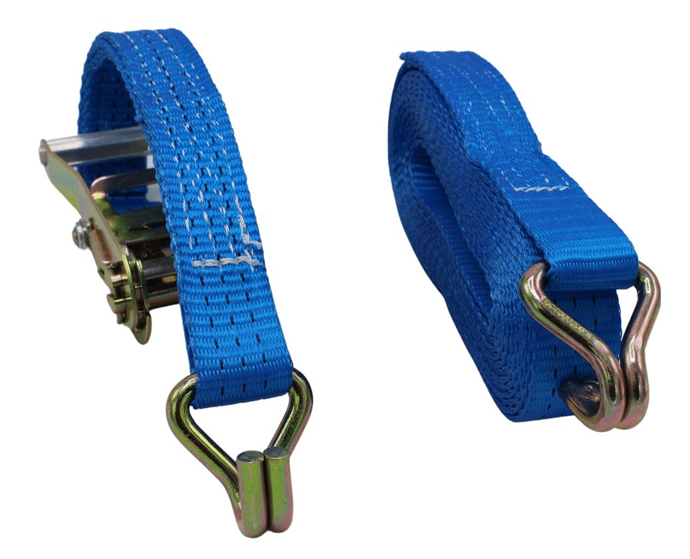

SIDE-A

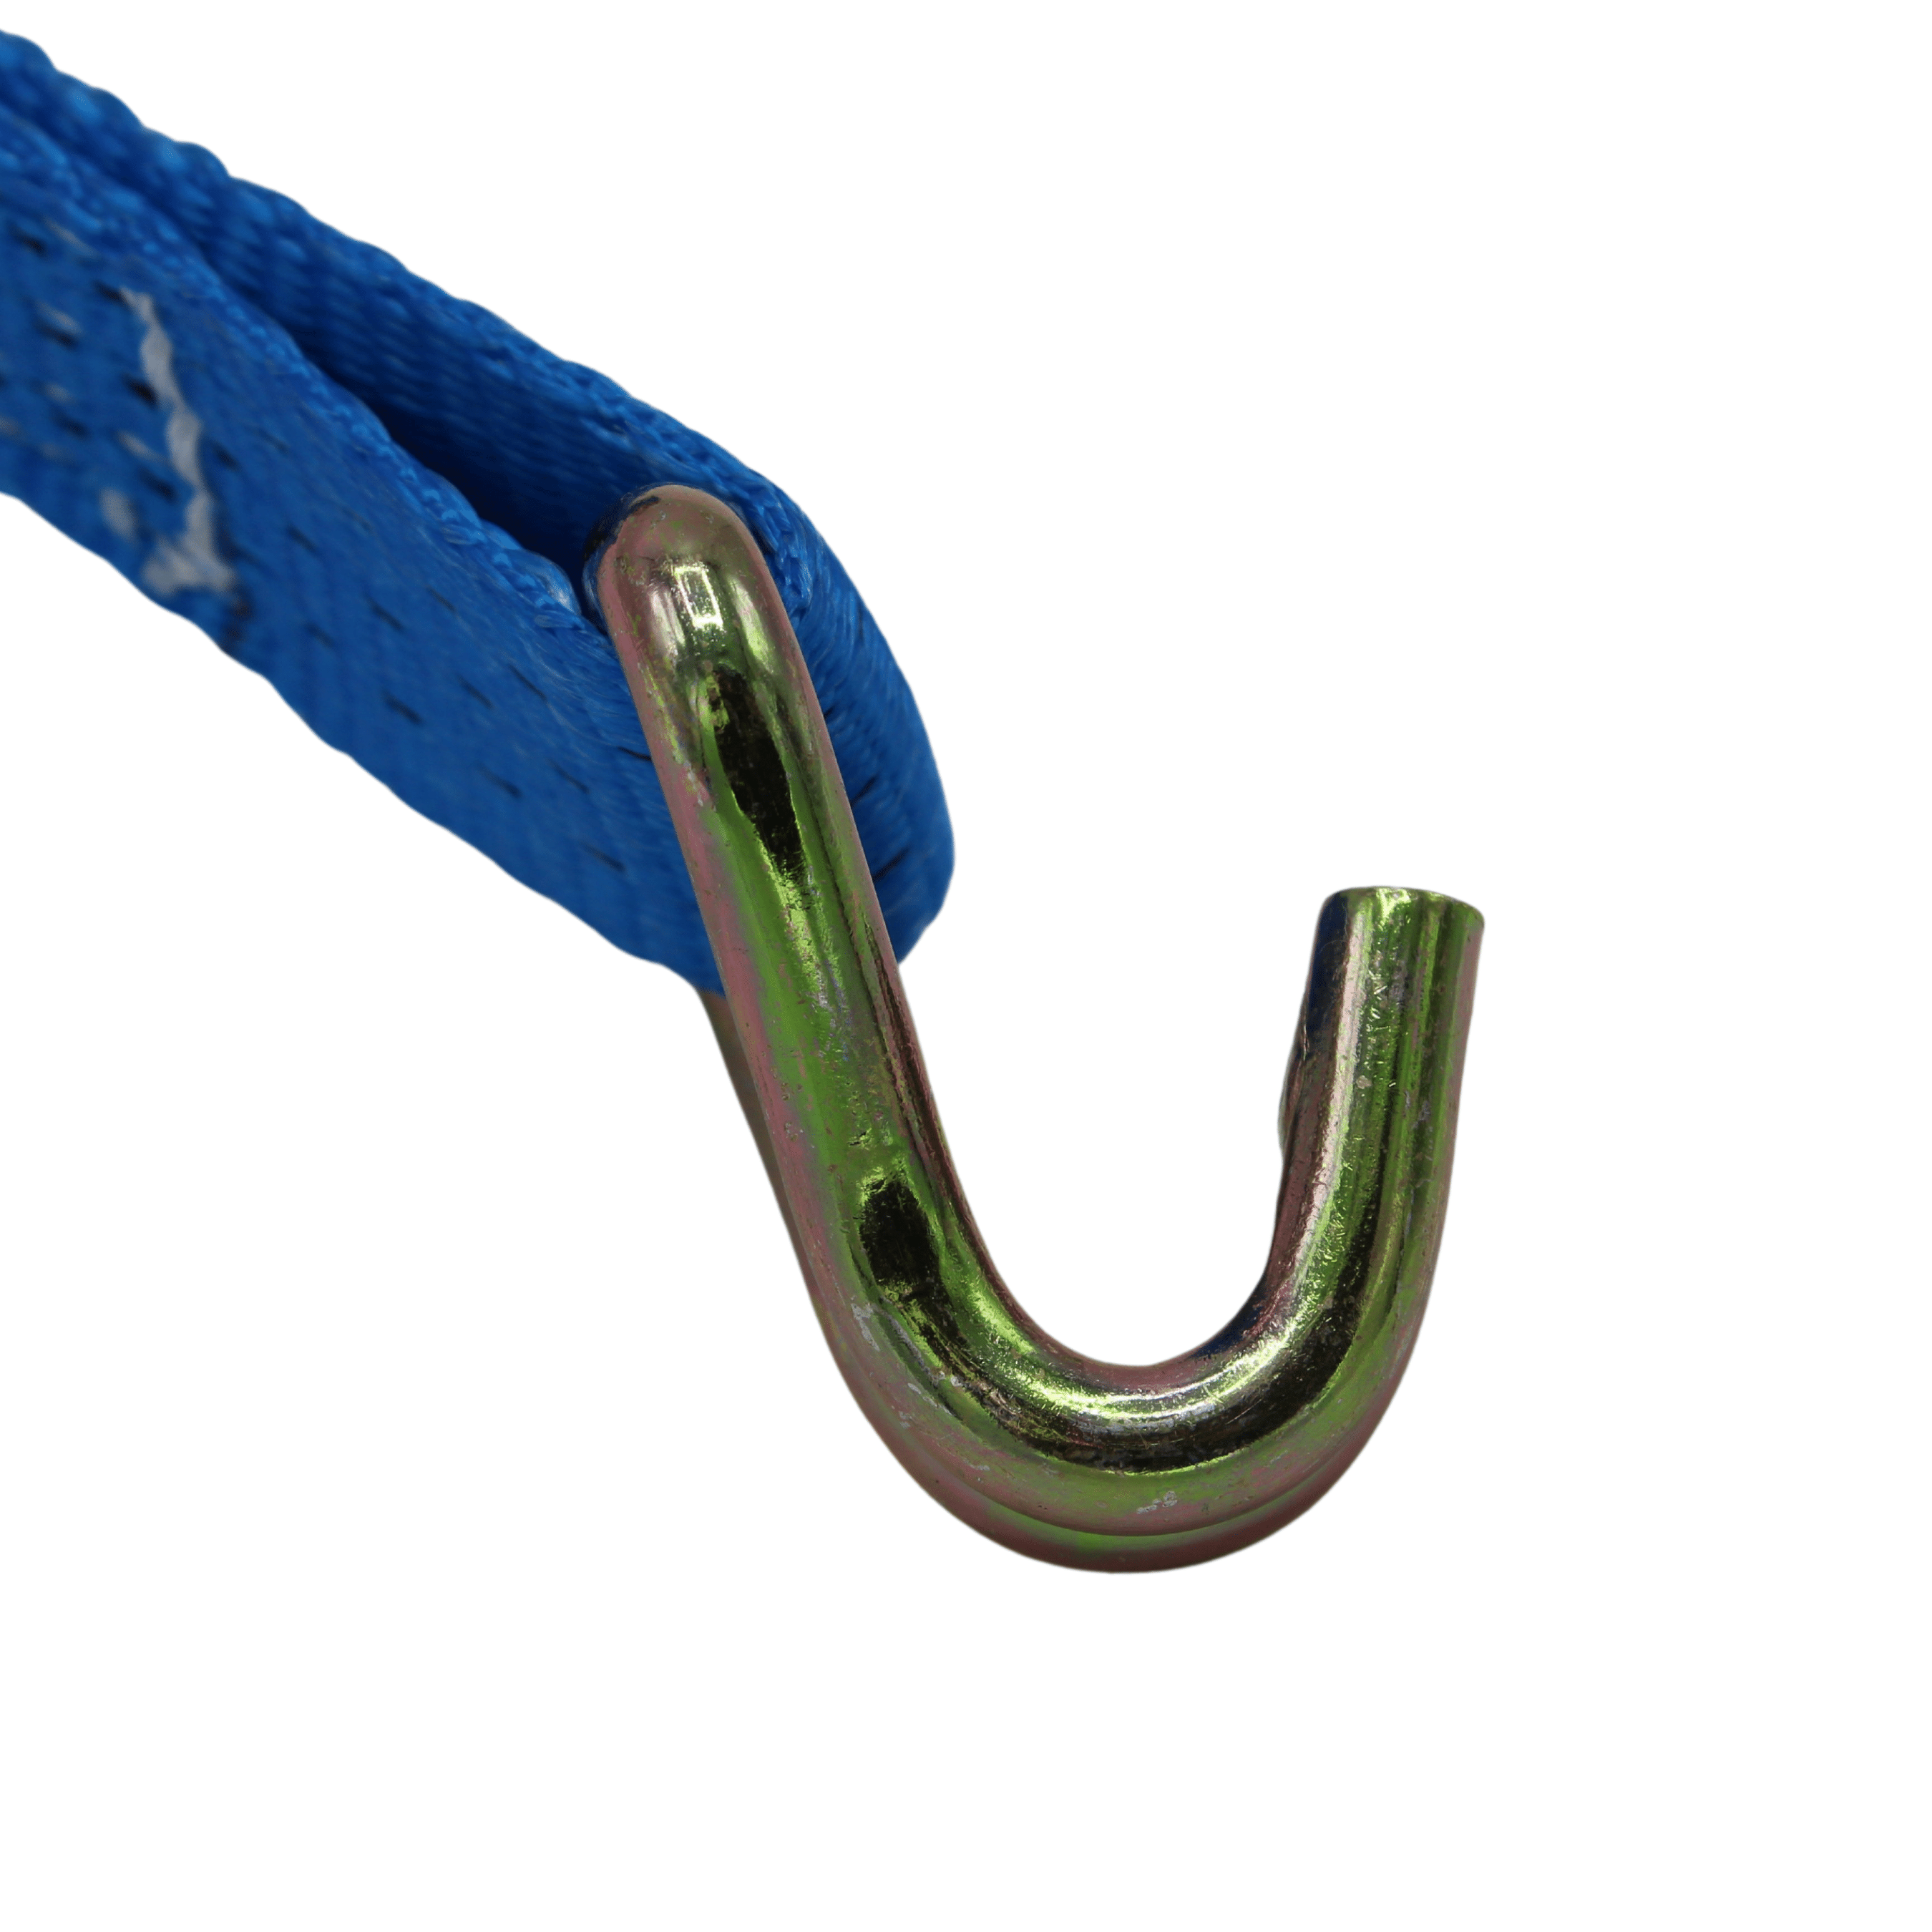

J-Hook opening

