

TETRA TESP-2003
Electric sump pump
2* connection, 220V, 1Ph, 60HZ, 1.5KW (2HP)
Max head 22.5M, Max cap 0.62m3/min
IMPA: 591627
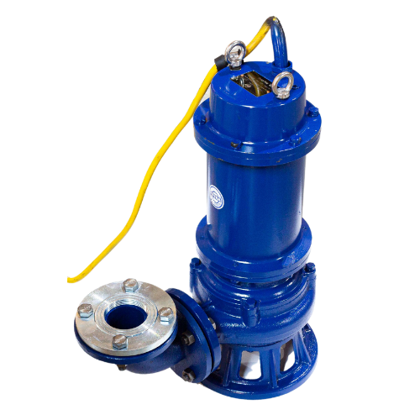
SKU:12299

Information: The TETRA TESP-2003 has a unique spiral structure and sharp edge design.This electric pump can be fully submerged in water to remove it. It’s can be used to keep basements dry, drain ponds or pump water from wells and tanks. The Electric sump pump draws water in from the bottom and discharges it trough a hose. The main advantage of the electric sump pump. Is that it operates efficiently and can be placed directly in the water, making it very effective for moving large volumes of water.

Product material:
- The shel is ordinary HT200 cast iron.
- The pump body part is ordinary HT250 cast iron.
- The cutting part is made of alloy material with Rockwell hardness above 48HR
- Domestic brand bearings or imported bran bearings.
Attention:
- Check wheter the cable is damages before use
- Check whether the pump is damaged in the process of transportation, resulting in leakage, damage, stuck, etc.
- Connect the power supply to the control cabinet of the protection device for use.
- Operation personnel and livestock must keep a dinstance of more than 15 meters.
- Absolutely prohibit people and pump in the samen pond.
- If you have any quostions during use, please contact our sales team.
- Avoid inhaling stones, screws, nails and other hard materials, can extend the service of life.
- The use of the environment mus be in flowing water.
- If the liquid is too little and the slag liquid to much, it must be started after adding water.
Efficiency comparison with conventional products:
- The red lines in the firgure shows the efficiency loss caused bij clogging continuous operation of conventional electric sump pump
- The green line shows the efficienct decrease caused by blockags during intermittent operation of conventional electric sump pumps. Backwashing of pumps can only bring temporary efficiency recovery.
- The blue line indicae continuous and efficient operation of the TETRA TESP-2003 Electric sump pump
Mode of operation:
Electronic Sump Pump structure:



Product Specifications:

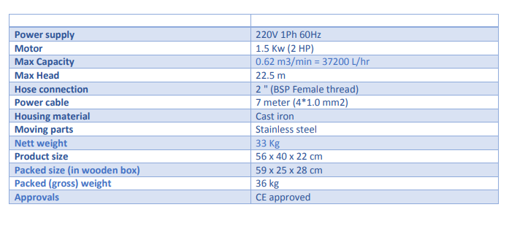


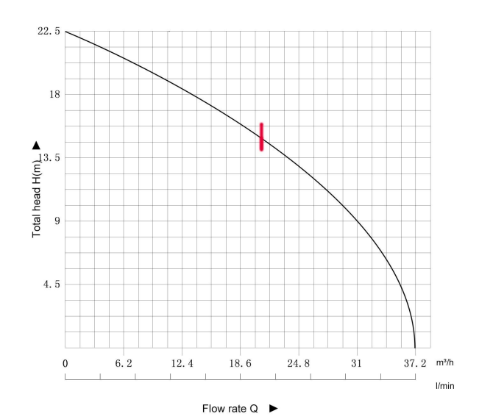
Accessories Display:

Check out our website to see more of our assortiment:

Impact Wrenches / Slagmoersleutels
Sockets / Slagdoppen
Drills / Boormachines
Angle grinders / Haakse slijpers
Die Grinder / Stiftfrezen
Needle Scalers / Naaldbikhamer
Needles / Naalden
Chisel Scalers / Beitelmachines
Chisels / Beitels
Saw Machines / Zaagmachines
Grease Guns / Vetpistolen
Riveters / Popnageltangen
Scaling Hammers / Bouchedeerhamer
Sanders / Schuurmachines
Caulking Guns / Kitpistolen
Quick Couplings / Snelkoppelingen
Vertical Grinders / Rechte Slijpers
Accessories / Accessoires
Parts / Onderdelen
www.technotrading.nl










Distributor of:

