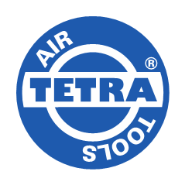TETRA HQ-73 XT

**Airless paint sprayer**

* Pressure ratio 73:1
* Max delivery 12,7 L/min
* Operating air pressure 3 – 6,5 bar
* Max discharge pressure 450 bar
* With noise reduction
* The unit comes as a complete set with 10 m paint spray hose and paint spray gun (including reverse A-clean nozzle)
* All spare parts available

